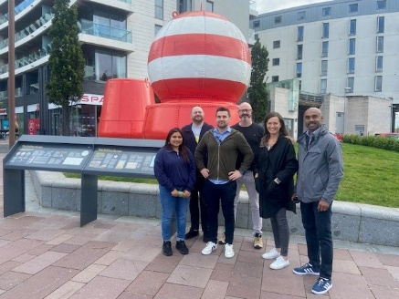
Reset your Steps Challenge
15th – 28th January 2024
Let’s start an evolution in 2024 giving the old New Year’s resolutions a miss this year (we never stick to them anyhow). Putting pressure on ourselves to dramatically change can be difficult. The very nature of the word evolution means ‘slow and steady’ so be kind to yourself by setting achievable and worthwhile goals. Don’t be too hard on yourself either - if it doesn’t work, just keep trying.

Ready, set, go!

Record your daily steps over the course of the first week (Mon 15th – Sun 21st) then challenge yourself in week two (Mon 22nd - Sun 28th) to increase your daily step count.

There’s no competing with anyone, it’s a race against yourself, set your own goals. Track steps using a fitness tracker, smart phone/watch or pedometer. Prizes to be won!
For further info & register for a participation pack contact Dianne.whyte@sustrans.org.uk no later than Sunday 14th January.

Get on Yer Bike Belfast
NEW for 2024. With Spring on the horizon, fancy getting ready to get on yer bike?
Belfast is the 5th most congested city in the UK yet two-thirds of adults would like to cycle. Cycling is cheaper than the car, faster than your feet and wheelie great for all ages.
Sustrans Leading the Way programme is here to help you get started; whether you’re a newbie, returner, vacation cyclist, new to the city, want to build confidence, like bike advice or got a question then join our live on-line drop-in sessions (via Teams) to hear more.
Contact Dianne.whyte@sustrans.org.uk to receive a joining link.

Monday 15th Jan 1.15pm – 1.45pm
Theme: No more wobbles.
Monday 22nd Jan 1.15pm – 1.45pm
Theme: Is that a bike lurking in the back of the shed?
Monday 29th Jan 1.15pm – 1.45pm
Theme: How not to waste money on clothing & accessories
Monday 5th Feb 1.15pm – 1.45pm
Theme: Look mum…..no cycle lanes!

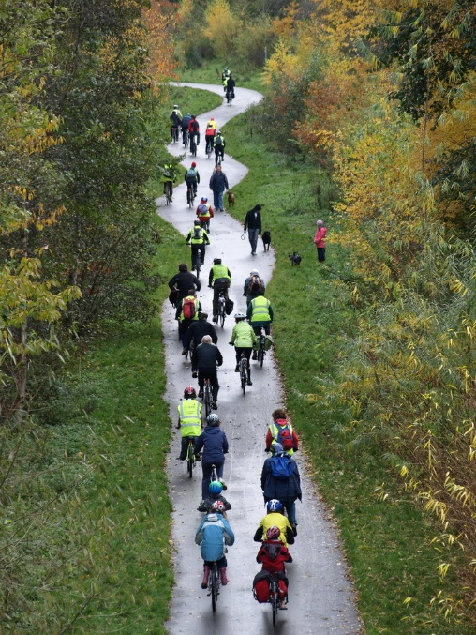

Book-as-you-go any of the following:
Helping you get from A to B
One to one advice & support to help you navigate active travel options and routes to work (cycling, wheeling, walking, public transport and car share). Bikes, clothing, accessories and security advice.

Absolute Adult Beginners
It’s never too late to learn a new life skill and cycling is one of them. Our friendly instructors will help you glide off into the sunset in no time. One to one tuition available at a time when suits you! Bikes & helmets can be provided.

Back on your Bike
Rebuild your confidence to get back cycling this autumn. One-hour, gentle paced session will start you on your journey again. Traffic free and Belfast locations vary. Bikes & helmets can be provided.

National Standard Adult Cycle Training Level 1-3
Take back control of your commute by building and refreshing your on-road cycling knowledge. This course is ideal for those wanting to get back into the flow of traffic, sharing the urban road with others as a responsible cyclist. Bikes and helmets can be provided.
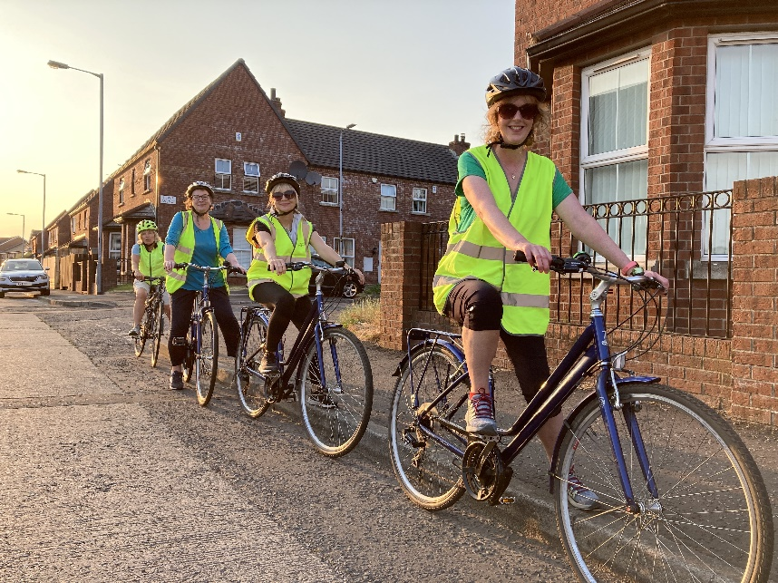

Try an e-Bike
Thinking of changing your existing bike, a potential Christmas gift, going electric or back cycling? Experience the brilliance of electric powered cycling on a Sustrans e-bike. 1 hour session, traffic free and Belfast locations vary
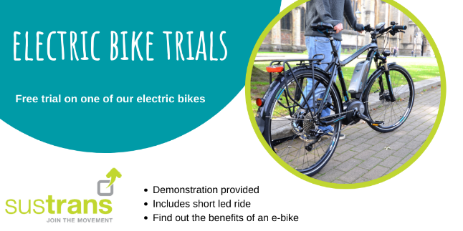

Borrow a Bike Scheme
Short term loans to try out your work, community or leisure commute (min. 2 weeks). Choose from standard city bikes, folding commuter, e-folding commuter or hybrid e-bikes. Helmet, panier & full kit provided. Pick up/return from Sustrans Active Travel Hub, CS Lewis Square only.
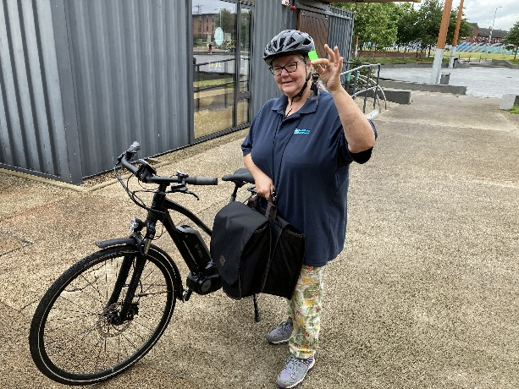

All our sessions are FREE. Book as you go.
For further details, got a question or book a session contact your Sustrans Active Travel Officer, Leading the Way with Workplace Active Travel (Belfast) Dianne Whyte Telephone: 07812 470791. Here to help!

