WINTER 2023/24.
Sustrans Leading the Way team is always on hand to answer questions, offer support, advice, free cycle skills training, route planning, bike loans and much more. Get in touch dianne.whyte@sustrans.org.uk or 07812 470791
Save money, reduce Co2 emissions and enjoy a stress free commute by joining NI Car Share. It’s free to register and super easy to find a travel buddy and at the same time reduce traffic and parking congestion.

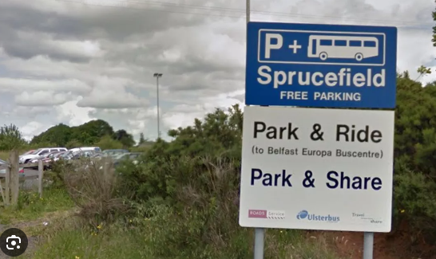
'Park and Ride/Share' car parks can be found at key road junctions throughout Northern Ireland. Save money, time and travel stress by completing part of your journey on public transport.
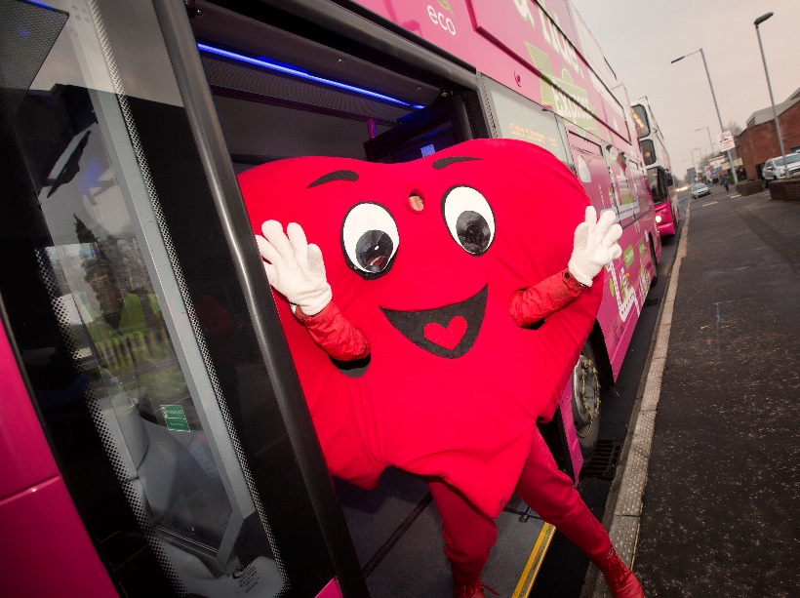
Get better connected with train & bus travel. Convenient and cheaper than car travel with a variety of discounted ticket options, contactless payments, comfy seats, free wifi, phone charging and much more. Work on the go or simply sit back and relax. Find your route with Translink and Belfast Glider

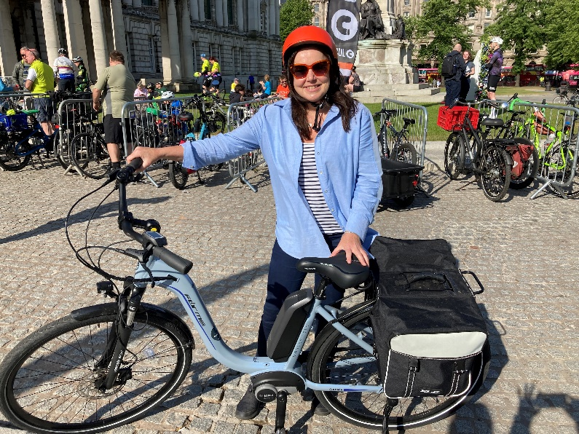
Pedal power journeys by bike! For shorter journeys, cycling is a brilliant way to travel with (saddle) bags of benefits.
Save money, quicker and easier than travelling by car, a cheap way to build exercise into the daily routine, better for physical and mental health, help tackle air pollution and it’s loads fun. Pick up a Belfast Bike from as little at £1 for 30 mins, 50 locations to choose from.
Plan a route and check cycle parking provision at your workplace before you get in the saddle.
Not sure where to park your bicycle in Belfast? There are lots of cycle hoops, stands covered cycle shelter and Translink secure cycle shelters dotted cross the city and more than you think!
Belfast’s first free 24 hour secure cycle parking facility ‘The Bike Yard’ can be found in Castlecourt Shopping Complex is perfect for access to shops, nightlife and Ulster University campus. Always remember to lock up the right way.
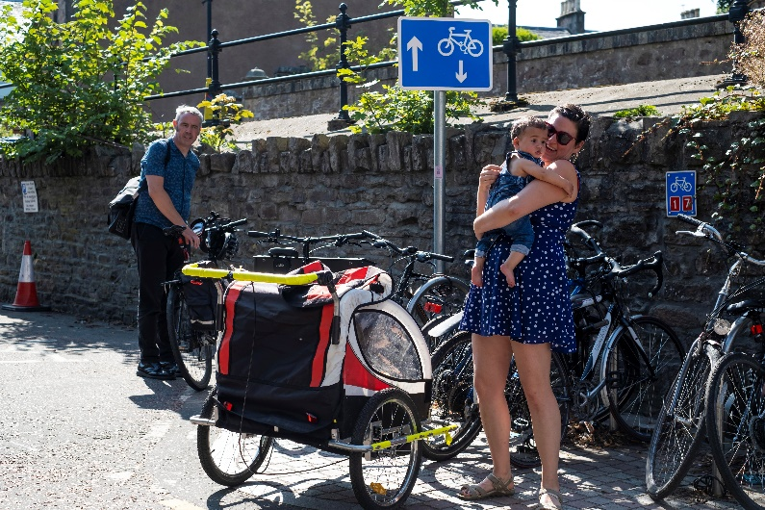

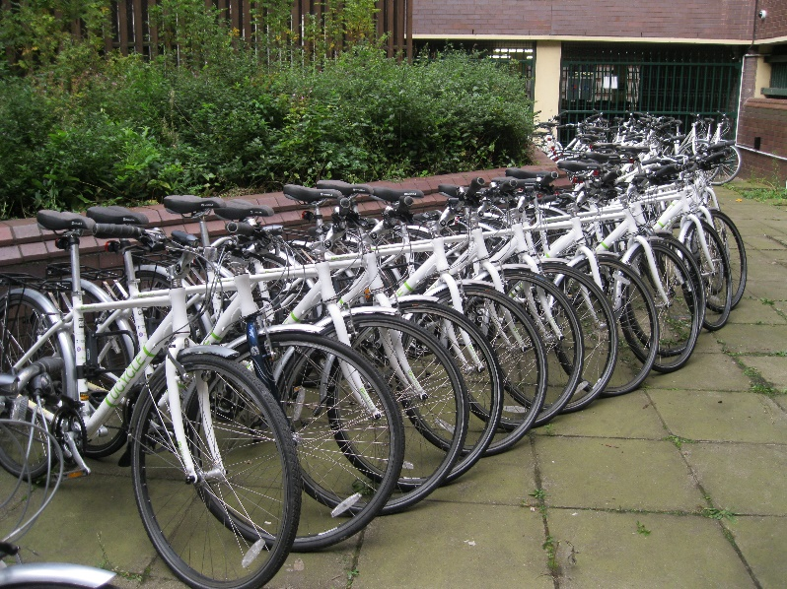
Bikes to suit your budget; new or pre-loved?
Do your research, buy a bike that’s right for you. Before parting with any money.
Did you know you can make a saving of up to 47% via Cycle2Work schemes. Check with your employer to see what they offer. Giving a pre-loved bike a new lease of life is good for the planet & you. Grab a deal on FreeCycle, Facebook Marketplace, local ads and social enterprises

Did you know there’s a huge potential for people to ride bikes in Belfast​
​
64.7 million car journeys in Belfast were <3 miles (2021)​
9.5 million trips were made on bicycles in Belfast (2021)​
50 Belfast Bike docking stations​
39 miles of traffic free routes​
Pop up cycle lanes and shared paths (only 2 miles of protected lanes!)​
43% of residents have an adult pedal cycle​
23% of men cycle every day compared to 11% of men​
47% of adults would cycle more with access to cycle training and led rides​

(Data taken from Belfast Walking & Cycling Index 2021)

