Travel Bytes

Active Travel & Sustainability Newsletter

*Winter Edition 23/24*

For more information visit the Travelling to Work page on The Loop

[Travelling to work (sharepoint.com)](https://bhsct.sharepoint.com/sites/nue/SitePages/Travelling-to-work.aspx)

Or email:

[TravelPlan@belfasttrust.hscni.net](mailto:TravelPlan@belfasttrust.hscni.net)

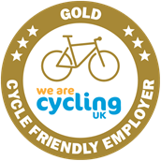

**Recent Events:**

**Valuing Social Work and Social Care Staff 2023**

**Self-Care Events**

The Travel Plan Team recenty attended this event where BHSCT wanted to recognise the importance of Social Work and Social Care staff and the vital role they play in the services the Trust delivers on a daily basis.

Each session offered staff the opportunity to:

* Have time away from the office environment with refreshments in a relaxing environment;
* Hear from one of our Directors/Co-Directors/Divisional Social Workers on the day;
* Access to a number of health and wellbeing stands on the day including getting your winter vaccination(s);
* Hearing a short session on the day about the importance of self-care with some practical tips;

We took this an opportunity to showcase the Cycle2work Scheme and the various initiatives that Sustrans offer **free** for staff to support their Health and Wellbeing –

* Ebike Trials
* Borrow a Bike Loan Scheme
* Cycle Training Level 1 & 2
* Women/Men into Cycling 6 week programme

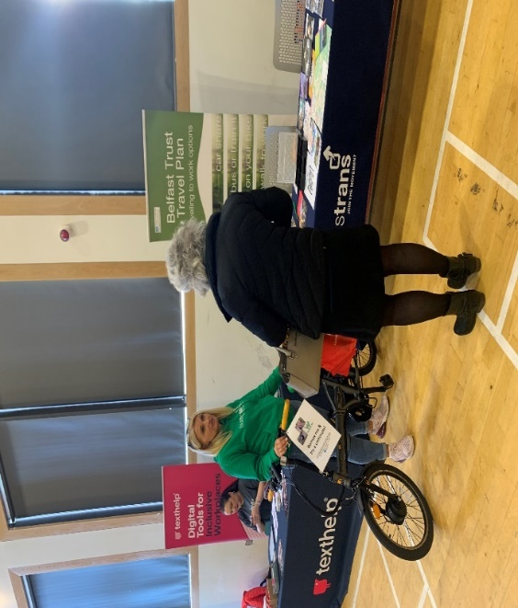

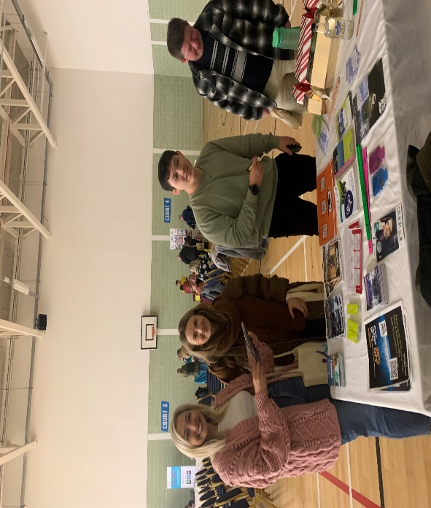‘Lets Get Active’ Drop In Clinic

Staff were inspired to make cleaner, greener, healthier and sustainable transport choices for everyday journeys recently at the ‘Let’s Get Active’ Drop In Clinic at Elliot Dynes basement Hub. The Travel Plan Team & Sustrans (UK’s largest walking & cycling charity) were on hand to provide complimentary festive refreshments and to talk more about;

* How to save money on everyday journeys
* Park & Ride (Black’s Road)
* Travel Cards
* Walking & route maps
* Lift Share
* Cycle To Work Scheme
* Staff secure cycle shelters/facilities
* Borrow a Bicycle scheme (e-bikes, folding bikes & more)
* Commute with confidence Sustrans Cycle advice, support & training
* **Complimentary gift ‘Active Travel Christmas Cracker’**

**Keep an eye out on The Loop for details of more of these clinics, coming soon to a site near you.**

**‘Let’s Get Active’ drop-in clinic**

**Elliott Dynes Health & Wellbeing Centre, Royal Victoria Hospital**

**Monday 27th November from 12 noon to 2.00pm**



**Tell us your story**

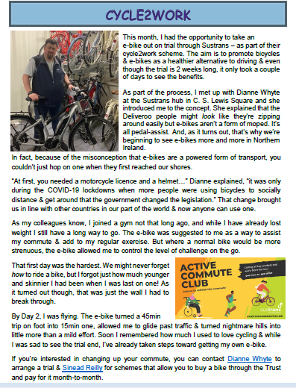

Dates for your diary

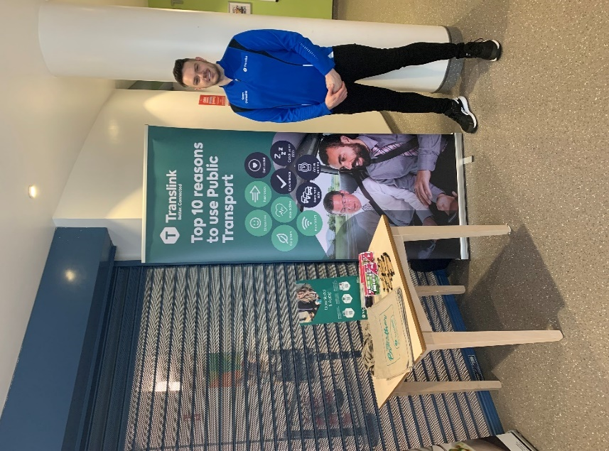Translink will be available for all your queries on Public Transport at, **Spoons Café Royal Hospitals** on:

* Tuesday 9th January from 12 - 2pm
* Tuesday 23rd January from 12 - 2pm

Come along for some freebies and expert advice that could save you money while travelling to work.

Have you heard of the Belfast Trust Bus/Train Saver Scheme ?

This is an annual travel card that allows you to save at least 20% on the cost of travel. This card also allows freedom of travel at weekends across any Translink network at weekends for FREE. Come along and fine out more on this super saving!

Mlink

The easiest and quickest way to purchase pre-paid tickets is to download the free mLink mobile ticketing app.The app is available to download on iOS and Android devices.

Black’s Road Park & Ride

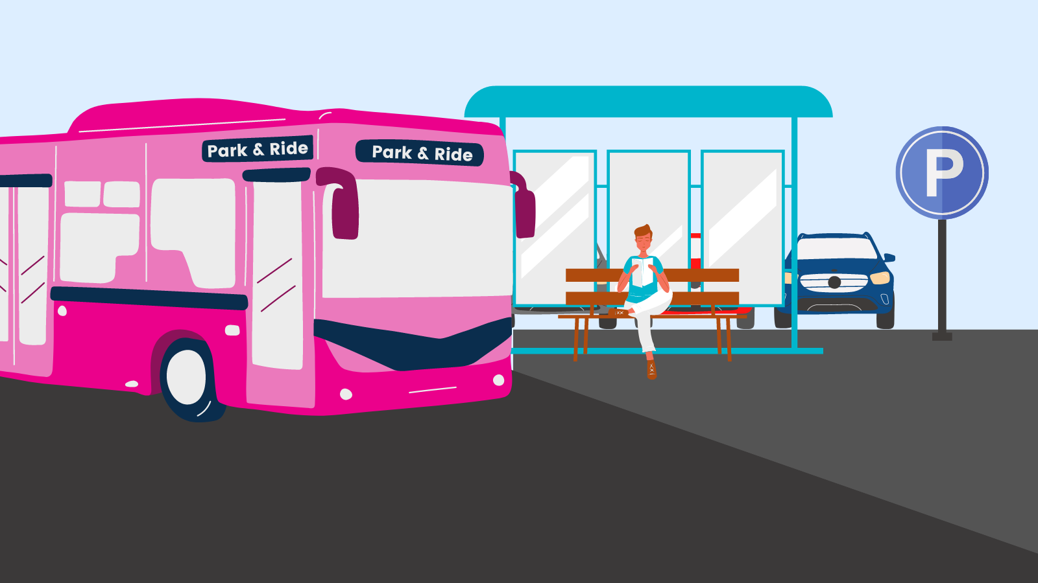

Translink operate a FREE park and ride for staff travelling to and from work. This runs from Black's Road to the Royal Hospital site and then to the Europa Bus Centre.

The timetable is available on [www.translink.co.uk](https://www.translink.co.uk/)- search for service 646. All services are also on the Translink Journey Planner App which can be downloaded from app store and google play.

If you continue to show Belfast Trust ID until further notice.

Glider Service - Translink Metro Route Map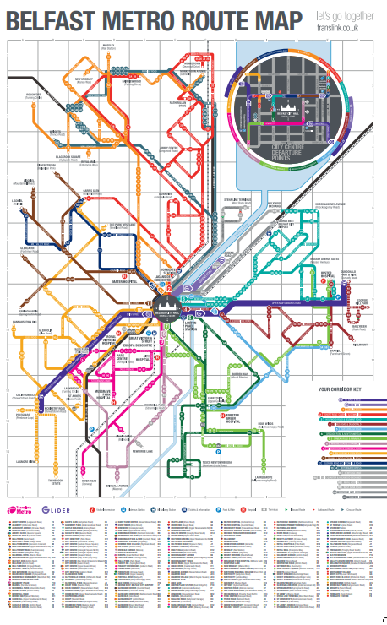

Scan QR code to see full map

The Glider is a cross city service with better access to the Royal Group of Hospitals running every 7-8 minutes throughout the working day from 05:30am to 12 midnight.

Glider integrates with other transport where you can park your bike at interchanges and key halts.The service also connects with residential areas seamlessly.

Priority at traffic lights and off vehicle ticketing allows for faster travel.

[Timetables (translink.co.uk)](https://www.translink.co.uk/timetables?routeHashCode=9146ce486f5785283942512e433c02d47312a7064ff353e4fff09a73b09856d0&transportMode=Bus&route=T0&direction=H)

**What’s on January 2024**

**Reset your Steps Challenge**

**15th – 28th January 2024**

Let’s start an evolution in 2024 giving the old New Year’s resolutions a miss this year (we never stick to them anyhow). Putting pressure on ourselves to dramatically change can be difficult. The very nature of the word evolution means ‘slow and steady’ so be kind to yourself by setting achievable and worthwhile goals. Don’t be too hard on yourself either - if it doesn’t work, just keep trying.

**Ready, set, go!**

Record your daily steps over the course of the first week **(Mon 15th – Sun 21st)** then challenge yourself in week two **(Mon 22nd - Sun 28th)** to increase your daily step count.

There’s no competing with anyone, it’s a race against yourself, set your own goals. Track steps using a fitness tracker, smart phone/watch or pedometer. Prizes to be won!

**For further info & register for a participation pack contact [Dianne.whyte@sustrans.org.uk](http://?) no later than Sunday 14th January**.

**Get on *Yer* Bike Belfast**

**NEW for 2024**. With Spring on the horizon, fancy getting ready to get on *yer* bike?

Belfast is the 5th most congested city in the UK yet two-thirds of adults would like to cycle. Cycling is cheaper than the car, faster than your feet and wheelie great for all ages.

**Sustrans Leading the Way programme** is here to help **you** get started; whether you’re a newbie, returner, vacation cyclist, new to the city, want to build confidence, like bike advice or got a question then join our live on-line drop-in sessions (via Teams) to hear more.

Contact Dianne.whyte@sustrans.org.uk to receive a joining link.

**Monday 15th Jan 1.15pm – 1.45pm**

**Theme: No more wobbles.**

**Monday 22nd Jan 1.15pm – 1.45pm**

**Theme: Is that a bike lurking in the back of the shed?**

**Monday 29th Jan 1.15pm – 1.45pm**

**Theme: How not to waste money on clothing & accessories**

**Monday 5th Feb 1.15pm – 1.45pm**

**Theme: Look mum…..no cycle lanes!**

**Book-as-you-go any of the following:**

***Helping you get from A to B***

One to one advice & support to help you navigate active travel options and routes to work (cycling, wheeling, walking, public transport and car share). Bikes, clothing, accessories and security advice.

**Absolute Adult Beginners**

It’s never too late to learn a new life skill and cycling is one of them. Our friendly instructors will help you glide off into the sunset in no time. One to one tuition available at a time when suits you! Bikes & helmets can be provided.

**Back on your Bike**  
Rebuild your confidence to get back cycling this autumn. One-hour, gentle paced session will start you on your journey again.  Traffic free and Belfast locations vary. Bikes & helmets can be provided.

**National Standard Adult Cycle Training Level 1-3**

Take back control of your commute by building and refreshing your on-road cycling knowledge. This course is ideal for those wanting to get back into the flow of traffic, sharing the urban road with others as a responsible cyclist. Bikes and helmets can be provided.

**Try an e-Bike**  
Thinking of changing your existing bike, a potential Christmas gift, going electric or back cycling?**Experience the brilliance of electric powered cycling on a Sustrans e-bike. 1 hour session, traffic free and Belfast locations vary**

**Borrow a Bike Scheme**  
Short term loans to try out your work, community or leisure commute (min. 2 weeks). Choose from standard city bikes, folding commuter, e-folding commuter or hybrid e-bikes. Helmet, panier & full kit provided.  Pick up/return from Sustrans Active Travel Hub, CS Lewis Square only.

All our sessions are FREE. Book as you go.

For further details, got a question or book a session contact your Sustrans Active Travel Officer, Leading the Way with Workplace Active Travel (Belfast) [Dianne Whyte](NULL) Telephone: 07812 470791. Here to help!