[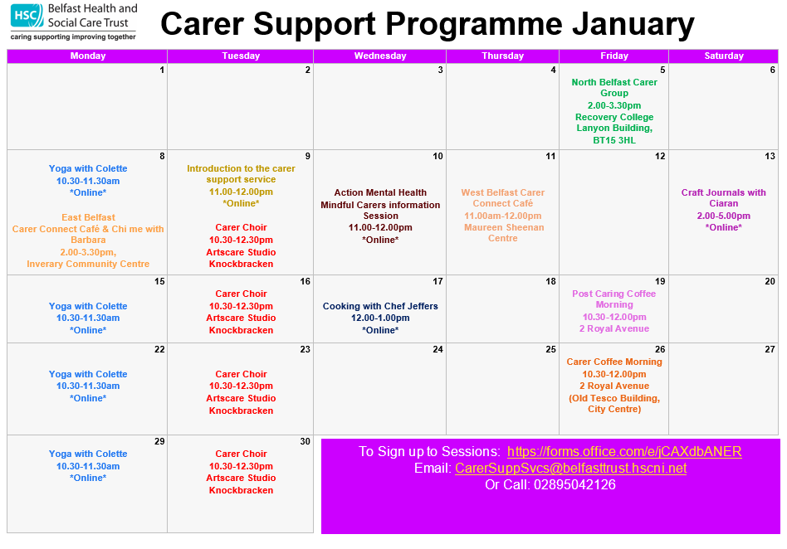](https://belfasttrust.pagetiger.com/jan24)