Ask the Bicycle Mechanic Workshop
Interactive maintenance workshop, with hands on demonstrations from our team of qualified experts. Learn ‘how to’ fixes and adjustments on your bicycle to keep it in tip top condition for everyday commutes. Tuesday 17th October, 6.30pm, CS Lewis Square Find out more and book a place
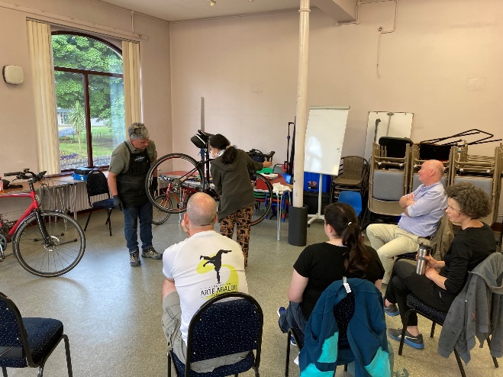
Get back into cycling programme
Based on our popular ‘into cycling’ programmes, this Autumn join us over 4 sessions packed full of practical cycling advice, support, knowhow and cycle training to get you saddle confidence once more. This programme is perfect for any adult eager to explore greenways, their local community and the commute to work. Starts Thursday 2nd November 6.30pm, CS Lewis Square Find out more and book a place
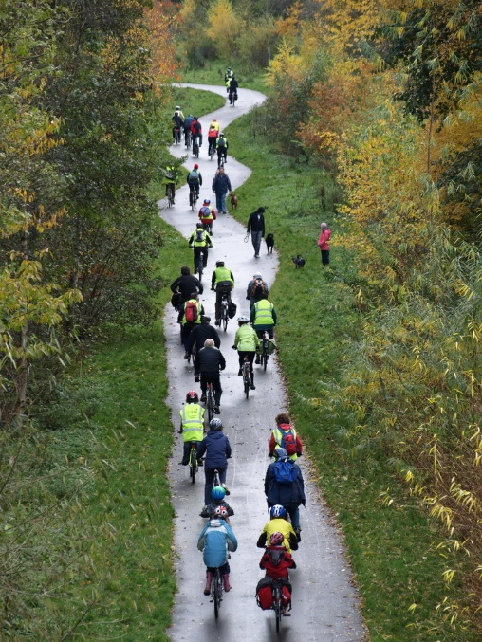

Lunchtime history walks - Belfast City Centre
Take an active break away from your desk, join Dianne & Declan for a lunchtime guided walk to many of the famous and not so famous landmarks in the city. Learn more about buildings, the people and history as we explore the sights and sounds of a bygone city.
Oct & Nov dates & city centre locations vary. Reserve your place

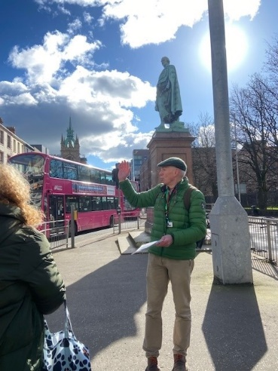

Fuel your own journey with the help of Sustrans. Book-as-you-go* any of the following:
Helping you get from A to B*
One to one advice & support to help you navigate active travel options and routes to work (cycling, wheeling, walking, public transport and car share). Bikes, clothing, accessories and security advice.

Absolute Adult Beginners*
It’s never too late to learn a new life skill and cycling is one of them. Our friendly instructors will help you glide off into the sunset in no time. One to one tuition available at a time when suits you! Bikes & helmets can be provided.

Back on your Bike*
Rebuild your confidence to get back cycling this autumn. One-hour, gentle paced session will start you on your journey again. Traffic free and Belfast locations vary. Bikes & helmets can be provided.

National Standard Adult Cycle Training Level 1-3*
Take back control of your commute by building and refreshing your on-road cycling knowledge. This course is ideal for those wanting to get back into the flow of traffic, sharing the urban road with others as a responsible cyclist. Bikes and helmets can be provided.
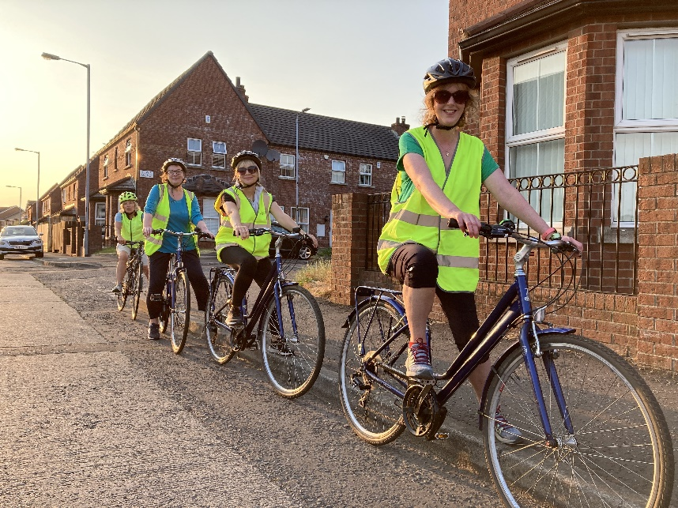

Try an e-Bike*
Thinking of changing your existing bike, a potential Christmas gift, going electric or back cycling? Experience the brilliance of electric powered cycling on a Sustrans e-bike. 1 hour session, traffic free and Belfast locations vary
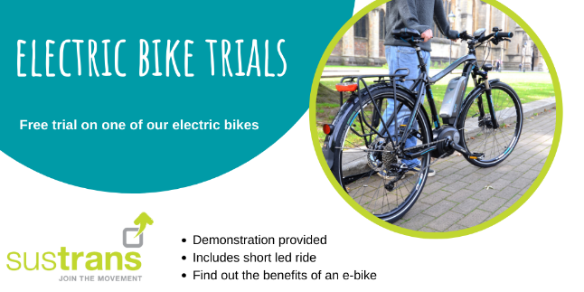

Borrow a Bike Scheme*
Short term loans to try out your work, community or leisure commute (min. 2 weeks). Choose from standard city bikes, folding commuter, e-folding commuter or hybrid e-bikes. Helmet, panier & full kit provided. Pick up/return from Sustrans Active Travel Hub, CS Lewis Square only.
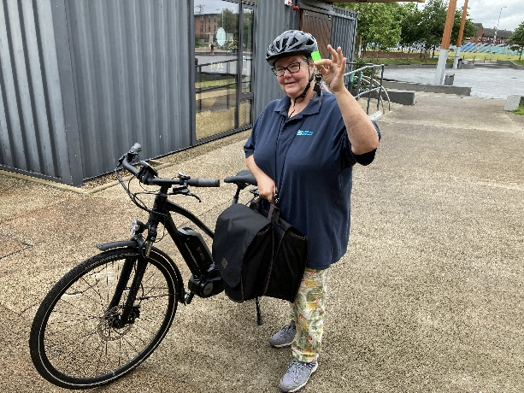

For further details or got a question contact your Sustrans Active Travel Officer, Leading the Way with Workplace Active Travel (Belfast) Dianne Whyte Telephone: 07812 470791. Here to help!

