

**Breastfeeding Support Groups**

**Belfast Trust**

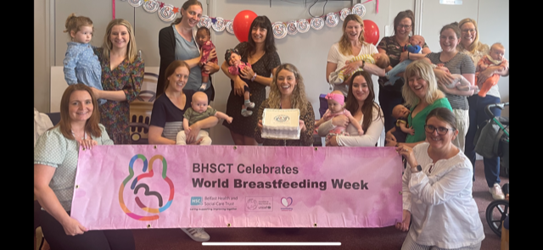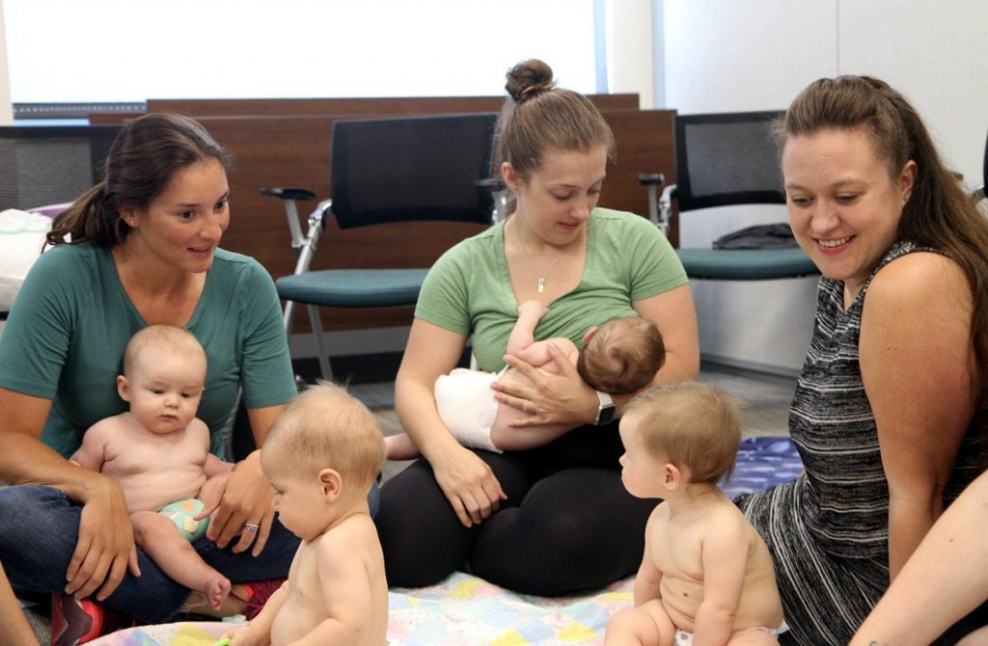

**BHSCT Infant Feeding Leads:**

**Barbara Spratt (Maternity)** (Mon – Fri 9am-5pm)

**Gemma McBride (Community)** (Mon,Tues,Thurs,Fri)

**Gillian Weir (Neonatal)** (Monday, Wednesday and Friday)

**Belfast Trust - Infant Feeding Team**

Tel: 02896150005

**Mum to Mum Breastfeeding Peer Support**

Tel. 02896150233

**Specialist Breastfeeding Support – Speak to midwife or Health Visitor**

**Belfast Health and Social Care Trust**

|  |  |  |  |  |
| --- | --- | --- | --- | --- |
| **Group Location** | **Type of meeting** | **Contact Details** | **Day** | **Time** |
| ***Virtual Breastfeeding Support Group*** | *Virtual*  *Microsoft Teams* | *Christine McPherson*  *Specialistbfsupport@*  *belfasttrust.hscni.net* | *2nd and 4th Mondays of the month* | *10am – 11am*  *(Times may vary)* |
| ***Newtownbreda Baptist Church*** | *Face to Face* | *02895040846* | *1st and 3rd Tuesday of the month* | *10.30am – 12.00pm* |
| ***Chichester Library – North Belfast*** | *Face to Face* | *02895040846* | *1st and 3rd Monday of the month* | *10.30am – 12.00pm* |

**Sure Start BF Groups**

|  |  |  |  |  |
| --- | --- | --- | --- | --- |
| **Group Name & Location** | **Type of group** | **Contact Details** | **Day** | **Time** |
| ***Glenbrook***  ***Wishing Well Family centre*** | *Face to face* | *02890712266* | *1st and 3rd Tuesdays* | *10am – 12pm* |
| ***Smile Sure Start***  ***529 Antrim Road*** | *Face to Face* | *02895042771* | *Every Tuesday* | *12pm – 1.30pm* |
| ***Saol Úr - 689***  ***Springfield Road*** | *Face to Face* | *02890324870* | *Every Monday* | *12pm – 1pm* |
| ***Shankill***  ***Honeysuckle***  ***Martin Centre 915Ballygomartin Road*** | *Face to face* | *02890729003* | *Every Thursday* | *1.30pm – 3pm* |
| ***Outer West - St. Theresa's Primary School*** | *Face to Face* | *02890300307* | *Every Wednesday* | *10.30am – 12.30pm* |
| ***South Belfast***  ***9 Lower Crescent*** | *Face to Face* | *02890942525* | *Every Thursday* | *1pm – 2pm* |
| ***Colin SureStart – Colin Family Centre.Pembrooke Loop Rd, Dunmurry*** | *Face to Face* | *02890601417* | *Every Wednesday* | *10.30am* |
| ***BreastStart Belfast Network Centre***  ***Templemore Ave*** | *Face to Face* | *02890963399* | *Every Thursday* | *1pm – 2.30pm* |

**NATIONAL VOLUNTARY HELPLINES & ORGANISATIONS**

* **LA LECHE LEAGUE NATIONAL HELPLINE** - **03451202918**

**National Website**: http://www.laleche.org.uk

**Local support helpline: 028 95818118**

**Local Website:** http://www.lalecheleagueireland.com

**Local Meeting Info** - up to date meeting details can be found onFacebook: <http://www.facebook.com/lllni>

* **NATIONAL BREASTFEEDING HELPLINE** – (9.30am- 9.30pm)

0300 100 0212

* **NATIONAL CHILDBIRTH TRUST (NCT) BREASTFEEDING HELPLINE**

0300 3300 771 (8am - MIDNIGHT) Enquiry Line – 0300 3300 770

Website: www.nct.org.uk

* **ASSOCIATION OF BREASTFEEDING MOTHERS HELPLINE**

0300 330 5453 (9.30am –10.30pm)

Website: www.abm.me.uk

* **BREASTFEEDING NETWORK SUPPORT LINE**

0300 100 0210 (9.30am –9.30pm)

Website:[**www.breastfeedingnetwork.org.uk**](http://www.breastfeedingnetwork.org.uk)

* **An excellent YouTube Video may help with key skills**:

Global Health Media production:

‘Attaching your baby at the breast’

**URL Code:** <https://youtu.be/wjt-Ashodw8>

Scan for You Tube Video