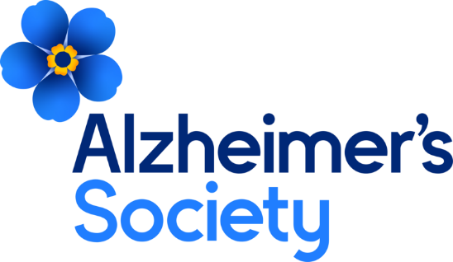

Dementia Voice Opportunities
in Northern Ireland

What is Dementia Voice?

Dementia Voice offers opportunities to people living with dementia and carers to use their personal experiences to help shape the work that Alzheimer's Society does and other local and national work with external organisations. It is also often referred to as 'user involvement'.

What do we do?

We want people affected by dementia to be at the heart of everything we do. We offer opportunities for people with a diagnosis of dementia and their family/carers to use their personal experiences, to help shape our work here at Alzheimer's Society, as well as with external organisations.

We have a wide range of activities people can do online, by email, phone or face to face, some regular, some occasional. For example, this could be through sharing your story, reviewing our publications or influencing change locally and nationally.

Dementia Voice Groups

Our network of Dementia Voice Groups are people living with dementia or carers, who share their experiences of dementia to inform services, campaigns and resources for people affected by dementia, both within Alzheimer’s Society and with external organisations. Recent examples are helping develop Alzheimer’s Society new 5 year strategy and working with the police to update the Herbert Protocol.

The National Groups involve people from England, Wales and Northern Ireland, and the Local Groups below involve people from Northern Ireland only.

​Groups meet online or face-to-face, some may be ongoing, welcoming new members as they go along, or time-bound, depending on local circumstances and needs. If you’ve never used Zoom before, don’t worry, we are here to help! While these groups are not for the main purpose of peer support, you can speak to your local Dementia Adviser about what local peer support is available.

Dementia Voice Local Groups (Northern Ireland)
Please contact us using the details below prior to attending so we can discuss the group with you, and let you know future dates in case there are any occasional changes to which week of the month the group will take place.
- NI Wide Dementia Voice Local Group (People living with dementia throughout Northern Ireland)
Online – Zoom
First Thursday of the month, 2pm-3pm
For information, please contact Julie-Anne Casson, Dementia Adviser: Julie-anne.casson@alzheimers.org.uk or nir@alzheimers.org.uk

- Dementia Voice Carer Involvement Group (Carers throughout Northern Ireland)
Meets face to face – Alzheimer’s Society Belfast Office, 30 Skegoneill Street, Belfast, BT15 3JD or nir@alzheimers.org.uk
First Wednesday of the month, 11pm-12 noon
For information, please contact Róisín Coulter, Dementia Adviser (roisin.coulter@alzheimers.org.uk) or Melanie Witherall, Dementia Adviser (melanie.witherall@alzheimers.org.uk) or email or nir@alzheimers.org.uk

Dementia Voice National Groups (England, Wales and Northern Ireland)
- Dementia Voice National Group (Carers)
Online – Zoom
Fortnightly, Fridays, 11am-12 noon
For more information, please contact yoursay@alzheimers.org.uk
- Dementia Voice National Group (People living with dementia)
Online – Zoom
Fortnightly, Wednesdays, 11am-12 noon
For more information, please contact yoursay@alzheimers.org.uk

Dementia Voice Survey Group (England, Wales and Northern Ireland)
You will receive an email with a short simple survey with questions to respond to every couple of weeks. You will have a week to respond, and you don’t have to reply to every email if you don’t feel it is relevant to you or your experience. The purpose of this group is to gather your thoughts and experiences to inform services, campaigns and resources for people affected by dementia. For more information, please contact yoursay@alzheimers.org.uk.

3NDWG (Three Nations Dementia Working Group) (England, Wales and Northern Ireland)
Supported by Alzheimer’s Society, the 3NDWG is a working group of people living with dementia across England, Northern Ireland and Wales. Members are based all across the three nations, creating a network of voices on dementia who can lead on regional projects. A steering group of 12 people with dementia drawn from the membership will lead the 3NDWG. The group also deliver fortnightly webinars open to anyone to attend on a range of topics from the perspective of people living with dementia. For more information, please contact 3NDWG@alzheimers.org.uk or visit https://www.3ndementiawg.org/

Dementia Voice Newsletter
A monthly newsletter that is emailed directly to you. Featuring opportunities to get involved, information about our campaigns and stories from people affected by dementia – to subscribe please email: yoursay@alzheimers.org.uk.

Occasional Opportunities (including media, sharing your story, recruitment, attending events)
You may only wish to be involved occasionally, and there are many ways you can do this, through sharing your story, being part of recruitment panels, attending events – there are a variety of opportunities! Other opportunities have included accessibility audits with Consumer Council, including Belfast International, City of Derry Airport and Belfast City Airport, and Stenaline. If you would like to be involved in this kind of opportunity, we can add your details to our Dementia Voice Database, along with some of the things you are interested in being involved in. For more information, please speak to your local Dementia Adviser, email nir@alzheimers.org.uk or phone 028 9066 4100.

For more information about Dementia Voice, please see our website:
https://www.alzheimers.org.uk/get-involved/dementia-voice

