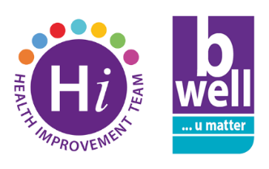
Swap Blue Monday for Feelgood February
Monday 16th January is “Blue Monday” – branded the most depressing day of the year - but there’s actually no evidence that this date is more challenging to our mental health than any other day. We all have good days and bad days and can experience poor mental health at any time of the year. Blue Monday was created as a marketing tool to encourage us to book holidays and buy ourselves treats to give us a lift; and you may see media articles or receive promotional emails along these lines.
Of course the period after Christmas can be challenging, especially this year when people may be feeling more financially pressured than ever before. But if you want to take a small step to improve your mental health then we have some suggestions which are proven to be much more effective than retail therapy:
- If finances are a worry then look into getting support and guidance. The B Financially Well section of the Bwell website is a good place to start.
- Try integrating the Take 5 Steps to Wellbeing into your daily life. Think of these as your “5 a Day” for your mental health. To find out more see the Community Wellbeing NI website.
- Many people experience anxiety. Explore some tips on how to manage this at the Managing Anxiety and Improving Wellbeing lunchtime workshop on Tuesday 21st February from 1pm – 2pm via MS teams.
- Show some kindness and compassion….to yourself! The short animation 'Getting to Know Your Brain: Understanding Stress and Self-Criticism' has been developed by the Health Improvement Team as a BHSCT staff wellbeing resource. Take five minutes to watch it here.
Further information including support services and self-help resources are available on the B Well staff health and wellbeing website.
If you, or someone you know, is in crisis and struggling to cope, call Lifeline and speak to a counsellor immediately 0808 808 8000. Textphone for deaf and hard-of -hearing Lifeline 18001 0808 808 8000.
For more information on the work of the Health Improvement Team visit our page here.

