Shine bright this Autumn
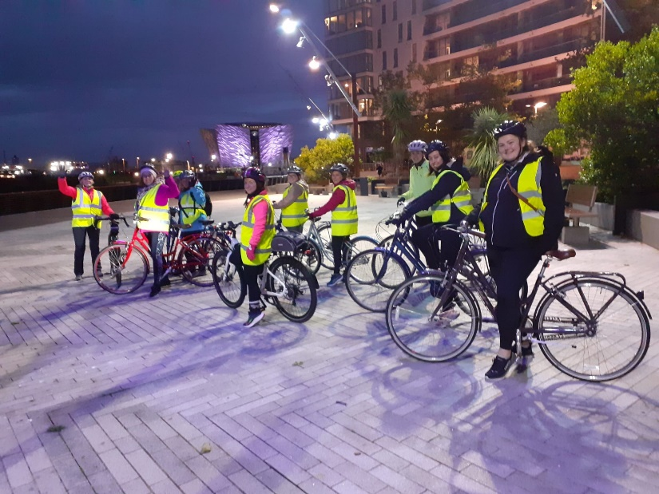
As the nights draw in sooner and the weather begins to turn, the idea of walking and cycling to work may feel less appealing. It’s hard to motivate yourself when it’s dark when you wake up and dark again when you finish work. When it’s raining and there’s a biting cold wind, catching the bus, train, walking or cycling may seem highly unappealing.
So how can you still actively travel this Autumn and Winter? Here are some top tips to stay motivated and keep moving under your own steam as the days get darker.
It’s quicker than you think;
Most people over-estimate how long it will take them to walk/cycle and under-estimate how long it takes to drive. Check out MapMyWalk or Google Maps.
Mix it up;
If you can’t travel actively for your whole journey why not combine with other forms of travel. For example, park further away from your destination or get off a bus stop early and walk the rest of the way. Car share with a colleague, a great way to reduce single occupancy trips.
Staying toasty against the elements;
Check the weather forecast the evening before and dress appropriately. No need for expensive clothing; warm layers, including over trousers are great for keeping dry, toasty and singing in the rain. Home - Sustrans.org.uk
Be bright & be seen;
When walking or cycling wear reflective or bright accessories. Use safe crossing points. If cycling it's the law to use front and rear lights and reflectors and remember cycling is not allowed on pavements, unless blue circular shared use signs are displayed. Refresh your Highway Code memory Rules for cyclists (59 to 82) | nidirect

