Could and e-bike help power your daily commute?
Electric bikes, or e-bikes as they are more commonly known can be a speedy (max 15.5mph), eco-friendly and cost-effective way to get around. Since the legalization in Northern Ireland was changed in 2020 in favour of the e-bike, sales have been booming and the trend shows no sign of slowing down.
In a time when the cost of living is on the increase, more and more adults eager to keep travel costs to a minimum therefore the e-bike is becoming a realistic option as a mode of transport. E-bikes are an investment for sure however many employers are offering an increase in how much employees can spend through Cycle to Work schemes.
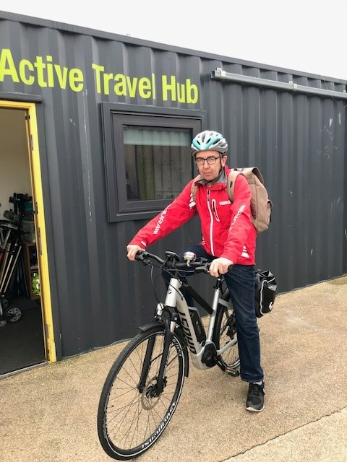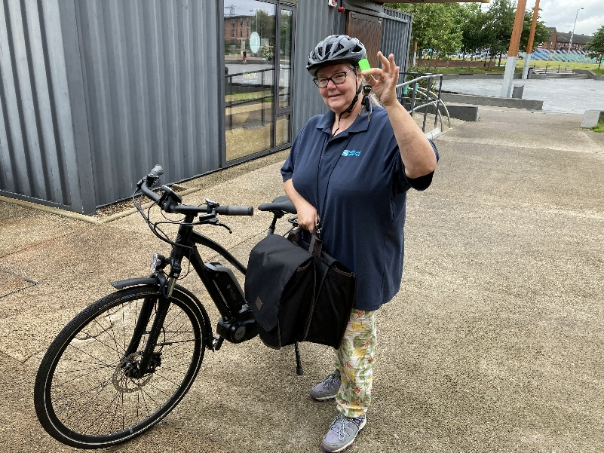

Electric bikes have many advantages, offer similar health benefits to regular cycling and should therefore be encouraged as a healthy alternative to relying on cars. They can increase the range you can cycle or make a long daily commute less arduous. They can allow you to keep up with friends or family members on groups rides. They can provide an excellent way to improve physical fitness and have the power to turn an ‘ooh’ into an ‘ahhhh’ when tackling steeper terrain or hills (of which there are many in Belfast).
But isn’t it cheating? Well, if you think cycling an e-bike is simply sitting in the saddle, switch it on and cruse along while the legs take a nap……then think again.
All e-bikes are pedal assist which means you need to be peddling for the battery power to kick in. Once you stop, so will the power. You can also ride the bike without power, as a regular bike but with the option to switch it on when you need it. Therefore, cycling to the shops or to work under your own steam is certainly not cheating and if anyone has spent time riding an e-bike will tell you that they’re so much fun.
Check out Sustrans - 9 reasons to ride an electric bike
Fancy having a test ride? As part of Sustrans Leading the Way with Workplace Active Travel programme, Sustrans have a variety of e-bikes available for a test ride and short-term loans. Try something new this Autumn with your work colleagues. T&C’s apply, find out more by contacting Sustrans Active Travel Officer (Belfast) Dianne.whyte@sustrans.org.uk.

