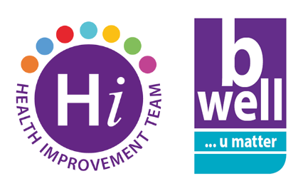
National Stress Awareness Day
Wednesday 2nd November is National Stress Awareness Day. Millions of us experience stress and can be damaging to our health and wellbeing but there are small steps we can take to help us manage in times of stress:
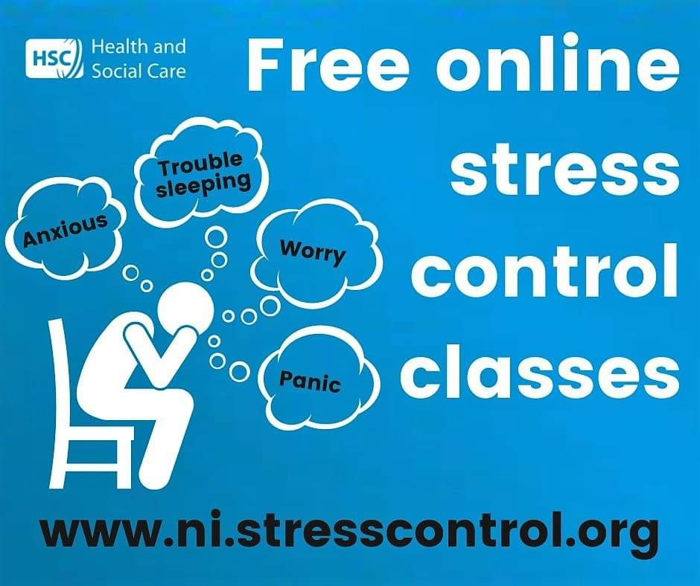
- A six week free online Stress Control course will begin on Monday 14 November and is open to all adults in NI. You don't have to register or log in, each class is 90 minutes long and available to view again for a limited period. To find out more about the 6 week course, go to www.ni.stresscontrol.org.
- If you’d prefer to attend an interactive workshop on managing stress the “Top Tips for Looking After Yourself” programme is delivered by the Health Improvement Team to Belfast Trust staff. Both face to face and online sessions are available over the coming months. Check out the Events section of the Public Health page on the Loop for forthcoming dates.
- You can also check out the resources and information to help you deal with stress on the B Well website. The Mind Ur Mind section includes a guided meditation, links to self-care tools and sources of support related to stress.
- The Health Improvement Team have a virtual bookshelf of Self-Help guides on common mental health issues and related topics which include Stress. These are also hosted on the BWell website and you can view them here.
Left unchecked, chronic stress can lead to mental and physical health problems. If you are concerned about the impact of stress on your health please speak to your GP or one of the sources of support listed in the Mind Ur Mind Toolkit.
For more information on the resources and programmes offered by the Health Improvement Team contact health.improvement@belfasttrust.hscni.net.

