[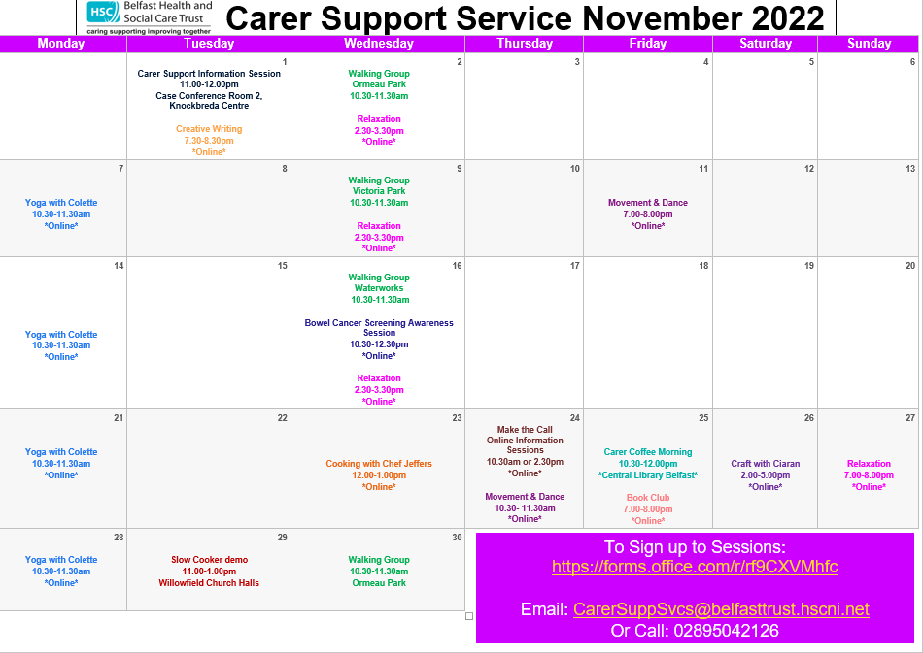](https://belfasttrust.pagetiger.com/november22/november22)