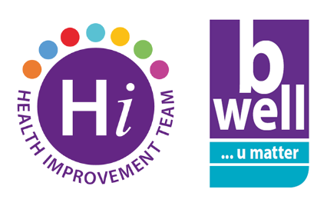
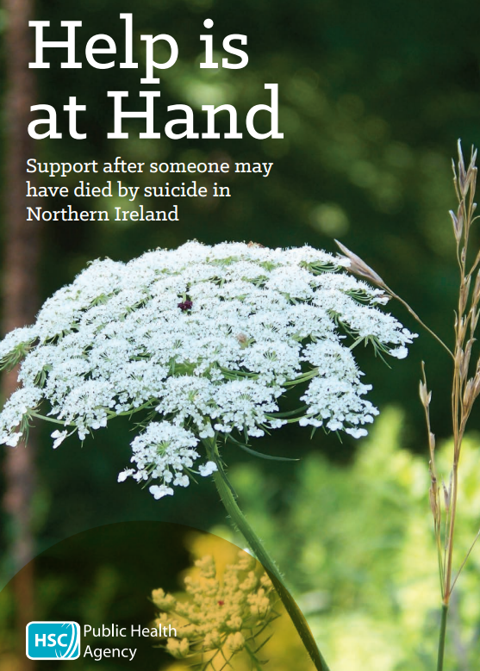
International Survivors of Suicide Loss Day
International Survivors of Suicide Loss Day is an opportunity for those who have been touched by bereavement though suicide to come together to find connection, understanding, and hope through their shared experience.
This year, International Survivors of Suicide Loss Day is Saturday, November 19th. The Public Health Agency’s booklet “Help is at Hand” offers practical advice and support following a sudden death. You can download the booklet here.
There are many organisations across the region offering support to those bereaved by suicide. Services can include group and individual support as well as complementary therapies and annual events bringing people together to remember those they have lost. A list of some of the services supporting those bereaved by suicide in the Belfast area can be found below.
- Belfast Trust Bereavement by Suicide Coordinator, Darren Whiteside - Tel: 02895 044 471/ 07701 279 263
- North Belfast Lighthouse, 187 Duncairn Gardens, BT15 2GF – Tel: 02890 755 070
- Shankill Extern Safe Project, Hammer Centre, Agnes St, BT13 1GG – Tel: 07483 156 380
- South and East Belfast New Life Counselling, 395-405 Newtownards Road, Belfast, BT4 1RH – Tel: 02890 391 630
- West Belfast Suicide Awareness and Support Group, 209 Falls Road, Belfast, BT12 6FB – Tel: 02890 239 967
Anyone bereaved by suicide can self-refer to the services listed above and can choose to attend any of the services irrespective of where they live within the City.
If you are concerned about a child (0-18) who has been bereaved by suicide you can access support from Barnardo’s Child Bereavement Service Tel: 02890 668 333.
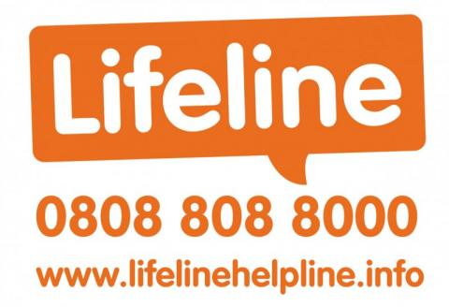
If you or someone you know are in distress or despair call Lifeline on 0808 808 8000. Lifeline is the Northern Ireland suicide prevention free phone helpline and is staffed by trained counsellors ready to take your call. 24/7.

