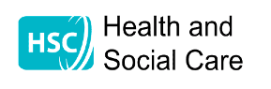
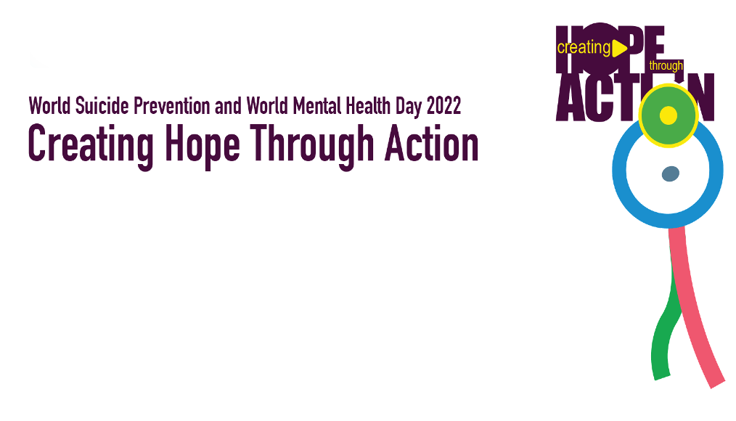
Mental Health and Emotional Wellbeing Webinar

As part of this year’s Regional Mental Health and Emotional Wellbeing campaign, in partnership with the six health trusts in NI and the Public Health Agency
This free interactive Webinar is open to everyone and will explore some actions that everyone can take to create hope. Learn more about the impact of social connections, self-compassion and resilience on our wellbeing
Delivered by Ed Sipler, Health Development Specialist, South Eastern Health & Social Care Trust
Wednesday 12 October 11.00am-2.00pm
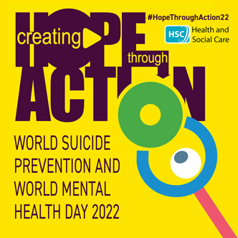
Sign up via Eventbrite by clicking the link or scanning the QR code below!
https://www.eventbrite.co.uk/e/creating-hope-through-action-tickets-429643223447

