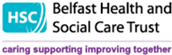

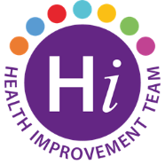

# 

# **Sexual Health Training Team**

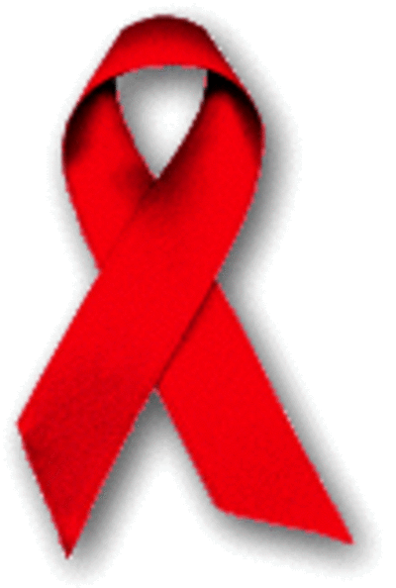**HIV AWARENESS SESSIONS OCTOBER-DECEMBER 2022**

HIV Awareness training is mandatory for all Health & Social Care Staff with direct patient and client contact.  The Sexual Health Training Team offers HIV Awareness sessions that are delivered online through MS Teams, making them easily accessible for Belfast HSC Trust staff. The sessions last approximately 2 hours and provide a good opportunity to learn more about HIV, raise personal and professional awareness of prevention, testing and treatment.

For further information or to book a place on your preferred course date please email:[**shealth.team@belfasttrust.hscni.net**](mailto:shealth.team@belfasttrust.hscni.net)

|  |  |  |
| --- | --- | --- |
| **OCTOBER 2022** | **NOVEMBER 2022** | **DECEMBER 2022** |
| Mon 3rd 2.00pm - 4.00pm  Wed 5th 10.00am -12.00pm  Mon 10th 2.00pm - 4.00pm  Wed 12th 10.00am -12.00pm  Wed 26th 2.00pm - 4.00pm  Fri 28th 10.00am -12.00pm  Mon 31st 2.00pm – 4.00pm | Fri 4th 10.00am -12.00pm  Tues 8th 2.00pm - 4.00pm  Tues 22nd 10.00am -12.00pm  Mon 28th 2.00pm - 4.00pm | Thurs 1st 2.00pm - 4.00pm  Tues 6th 2.00pm - 4.00pm  Fri 9th 10.00am -12.00pm  Mon 12th 2.00pm - 4.00pm  Wed 14th 10.00am -12.00pm |