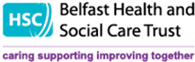

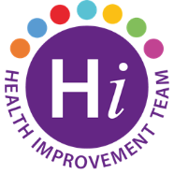

# 

# **Sexual Health Training Team**

**HIV AWARENESS SESSIONS 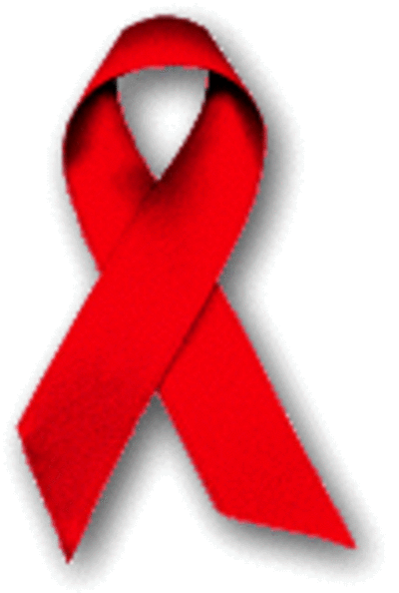JANUARY 2023**

HIV Awareness training is mandatory for all Health & Social Care Staff with direct patient and client contact.  The Sexual Health Training Team offers HIV Awareness sessions that are delivered online through MS Teams, making them easily accessible for Belfast HSC Trust staff. The sessions last approximately 2 hours and provide a good opportunity to learn more about HIV, raise personal and professional awareness of prevention, testing and treatment.

For further information or to book a place on your preferred course date please email:[**shealth.team@belfasttrust.hscni.net**](mailto:shealth.team@belfasttrust.hscni.net)

|  |
| --- |
| **JANUARY 2023** |
| Wed 4th 2.00pm – 4.00pm Fri 20th 10.00am -12.00pm  Fri 6th 10.00am -12.00pm Mon 23rd 2.00pm – 4.00pm  Mon 9th 2.00pm – 4.00pm Wed 25th 10.00am -12.00pm  Fri 13th 2.00pm – 4.00pm Fri 27th 2.00pm – 4.00pm  Tues 17th 10.00am -12.00pm Tues 31st 10.00am -12.00pm  Wed 18th 2.00pm – 4.00pm |