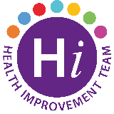**Be Mouth Aware**

November is Mouth Cancer Action Month!

Mouth cancer affects over 8300 people each year in the UK and is twice as common in men as in women. Mouth cancer can affect the face, neck, lips, cheeks, gums, tongue, the floor of the mouth and the roof of the mouth.

The good news is that with early diagnosis the chances of surviving mouth cancer are **9 out of 10**. That’s why if you notice any white or red patches, unusual lumps and swellings in the mouth and neck or ulcers that don’t heal within 3 weeks then it’s important to visit your dentist or GP. If in doubt, get it checked out!

For more information visit:

[Mouth Cancer Action Month | Home | Oral Health Foundation (dentalhealth.org)](https://www.dentalhealth.org/mouthcancer)

[Mouth Cancer Foundation | Helpline: 01924 950 950](https://www.mouthcancerfoundation.org/)

For FREE, confidential support to help you stop smoking, staff and patients can contact the Stop Smoking Team on:

Telephone: 028 9504 6714

Email: [stopsmoking@belfasttrust.hscni.net](mailto:stopsmoking@belfasttrust.hscni.net)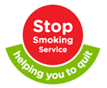

**Alternatively, you can:**

Contact your GP or local Pharmacy

Or go to: [Stop Smoking (stopsmokingni.info)](https://www.stopsmokingni.info/)