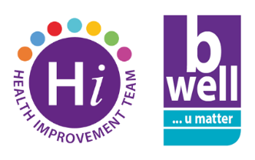
World Suicide Prevention Day 2022
Saturday 10th September is World Suicide Prevention Day and this year’s theme is “Creating Hope Through Action”.
What Action Will You Take?
There are several things you can do to help prevent suicides both within the Trust and in the wider community:
- Save the Lifeline number into your phone could help save a life. Lifeline is the regional 24/7, free crisis helpline for anyone in distress or despair and is staffed by trained counsellors. The number is 0808 808 8000. Save it to your mobile now - you never know when you or someone you know might need it
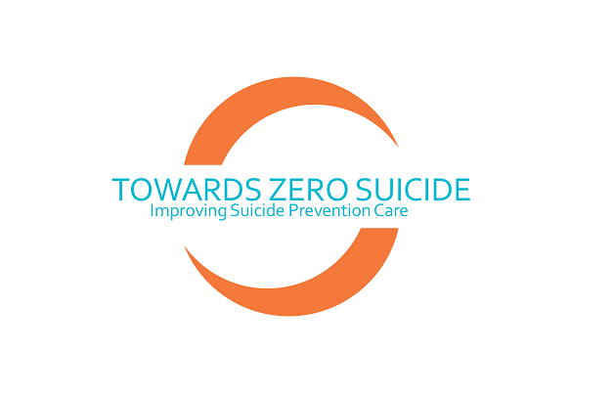
- To learn lifesaving skills take 20 minutes out of your day to complete the Towards Zero Suicide training available through the HSC Learning website www.hsclearning.com. This course teaches a simple 3 step model for suicide prevention and uses interactive videos to help you practice in a range of scenarios at work, at home and in the community. As a Trust we are committed to a Regional Towards Zero Suicide approach focusing on patient safety to reduce suicides within mental health services and encouraging as many staff as possible to complete this training is an important part of this approach.
- If you’ve completed the Towards Zero Suicide training and would like to develop your knowledge and skills further, you may benefit from taking part in more advanced suicide prevention training courses such as Connections or ASIST. See the Health Improvement Training Guide for more information on these courses.

If you’re looking for information and resources regarding suicide prevention and mental health please see the Mind ur Mind section of the B Well website. You can also check out our range of Self Help guides here which include topics such as depression, self-harm and stress.
If you or someone you know are in immediate danger of suicide, seek help immediately. Either call Lifeline on 0808 808 8000 or call 999.
For more information on the work of the Health Improvement Team visit our page here.

