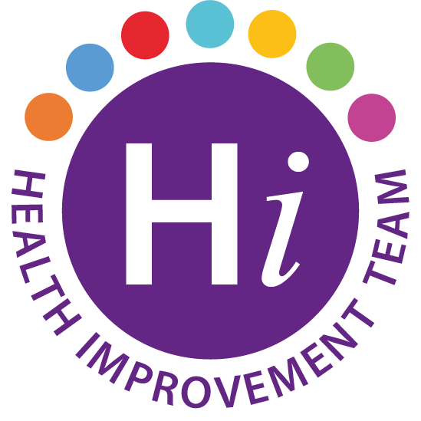
Menopause Awareness Session – Hormone Replacement Therapy and alternative remedies
Tuesday 4th October 2022, 1pm-1.30pm
Via MS Teams
Presented by: Philomena McFall: Menopause Nurse Specialist
To register to attend please email: health.improvement@belfasttrust.hscni.net

Please visit b well Lets Talk Menopause to view the Menopause and Me Digital Toolkit which includes:
-Guide for Managers
-Guide for women
- HRT and alternative support
- Signposting to support services.

