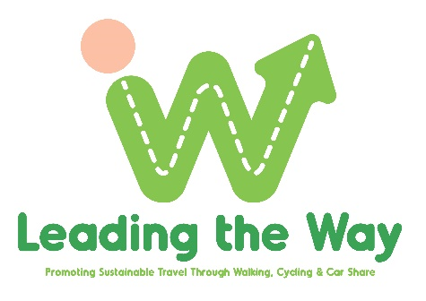
What’s coming up September 2022

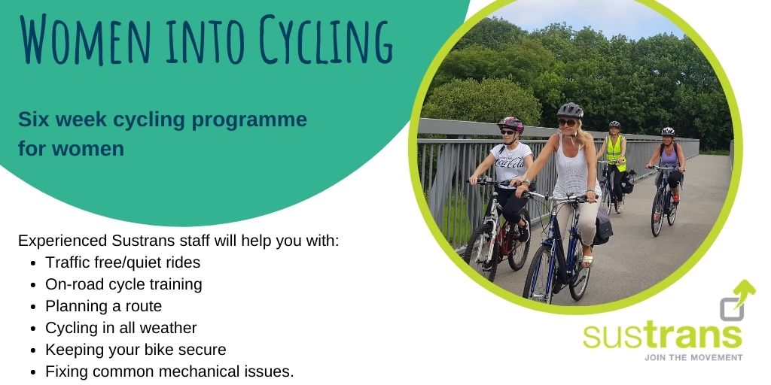

Due to popular demand. Gain confidence back in the saddle with other like-minded women eager to get cycling again. This 6-week programme is packed with everything you need to dispel those myths, have fun and get moving.
Location: Sustrans Active Travel Hub, CS Lewis Square. Bikes & helmets provided on request.
.Choose from:
Starting Tuesday 6th September 6.30pm – 8.30pm
Book here: https://www.eventbrite.com/e/391578390507
Or
Starting Friday 16th September 11am – 1pm
Book here: https://www.eventbrite.com/e/391584378417
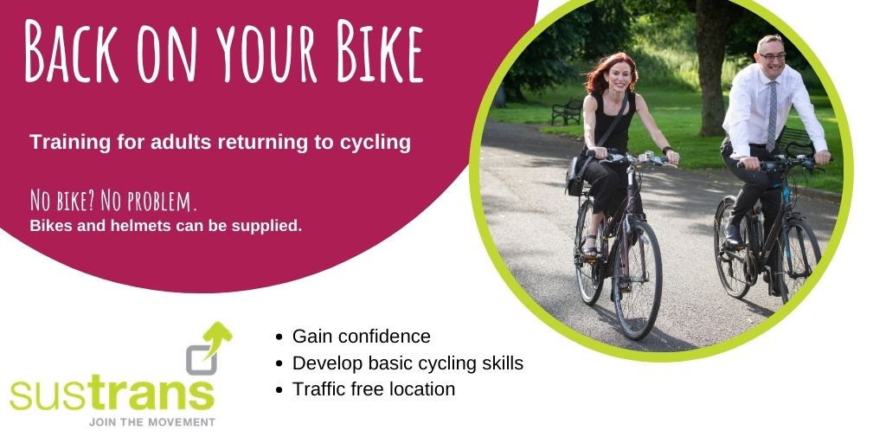

This one hour session if perfect for adults who haven’t cycled since childhood or for a while. One to one or small group sessions can be organised ANYTIME. Bicycles can be provided on request. Traffic free locations vary (Belfast only).

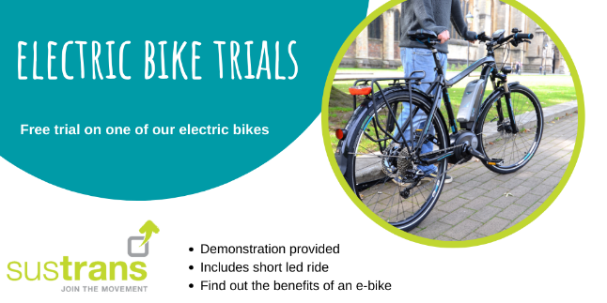

Thinking about buying an e-bike? Come and experience a traffic free session on one of Sustrans e-bikes at CS Lewis Square. Contact Dianne.whyte@sustrans.org.uk to arrange a session ANYTIME.
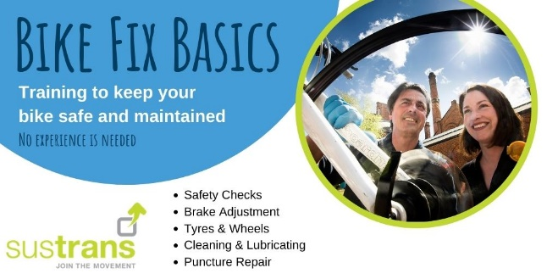
Don’t let fear of a puncture deflate your reason to cycle. Gain new knowledge, skills and pick up some complimentary saddle bag essentials for your journey. Suitable for beginners & intermediates
Sunday 25th September 2pm – 4pm. EastSide Visitors Centre, CS Lewis Square, Belfast
Book here: Bike Fix Basics Registration, Sun 25 Sep 2022 at 14:00 | Eventbrite
Borrow a Bike Scheme.
Fancy test riding your work or leisure commute by bike? Borrow (for free) one of Sustrans bikes for up to 2 weeks. Choose from a range of bikes including city step through, electric hybrid, folding commuter & e-commuter bikes. Each bike comes complete with helmet, panier, lights, bell, basic tool kit, lock etc.
This is ideal if you are thinking of changing your existing bike, moving to electric or getting back into cycling. Terms and conditions apply.
Also did you know that at Halfords you can book a e-bike test drive for up to 6 hours? Try before you buy is certainly the way to go.
For more details & book a bike contact Dianne.whyte@sustrans.org.uk

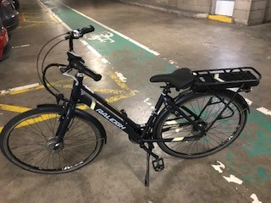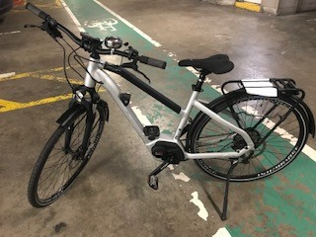
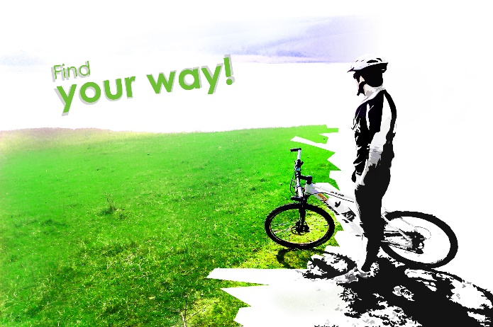
Can we help? Finding the right route for your commute (walking or cycling) can be a daunting task but there are lots of simple online apps and links to access.
Here are just a few. Komoot Google Maps CycleStreets Outmore NI The NCN Cycle Routes - Belfast Park and Share or Park and Ride. Check out Sustrans, chat to friends, neighbours and colleagues to see how they travel.
Still not sure? contact Dianne.whyte@sustrans..org.uk.

