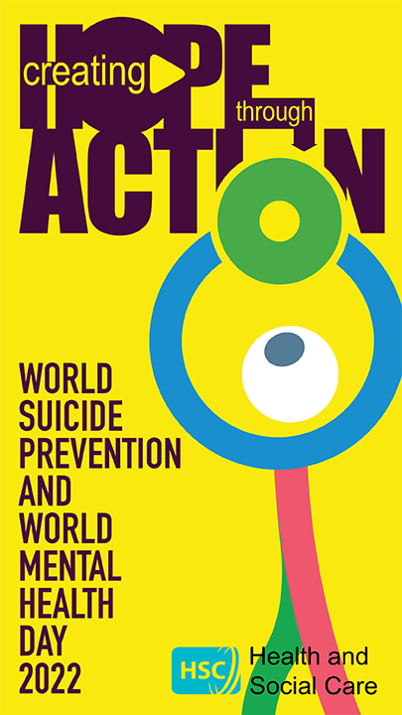

Regional Mental Health and Emotional Wellbeing Campaign 2022

Creating Hope Through Action

The six Health Trusts in Northern Ireland, in partnership with the Public Health Agency (PHA), invite you to join our Autumn 2022 campaign Creating Hope Through Action.

We are encouraging community and voluntary partners to organise an event that aims to “create hope through action”. We also hope that you can support the campaign by sharing information and posting on social media using the hastag #HopeThroughAction22.

How we can help?
- We have lots of tips, ideas, practical advice and downloadable resources to help you plan your event in our Coffee & Connect event pack
- We may be able to provide flyers and other mental health and emotional wellbeing promotional resources to give out at your event
- We can help you to promote and raise the profile of your event

Let us know about your event.

Please complete the attached registration form and email it back to Clare.Flynn@belfasttrust.hscni.net

Help us to celebrate this important campaign to create hope throughout NI, by encouraging people to take action.

Please ensure all events adhere to public health guidance to limit the spread of Covid-19. See the Public Health Agency website for current guidance.

Event Registration Form
Regional Mental Health Campaign

Name of Event & Organisation

Brief Description of Event

Contact details for organiser (please supply email address)

Date / Time / Venue

Is your event… (delete as appropriate)

A closed event – members / invite only

Open to all

If your event is open to all, we may be able to help you publicise your event through our networks. Would you be interested in support to publicise your event?

Yes / No (delete as appropriate)

Our Coffee & Connect resource pack available here includes some tips and downloads.

We may also be able to provide some mental health and emotional wellbeing flyers and resources for your event.

Would you be interested in receiving these?

Yes / No (delete as appropriate)

Please return this form to Clare.Flynn@belfasttrust.hscni.net

