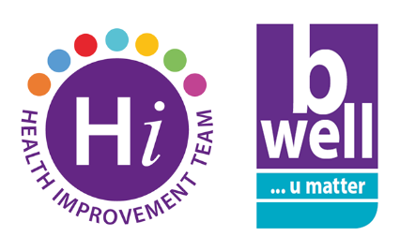

#Walk this May

May is National Walking Month & we would love if you could promote #WalkThisMay.

This can be done by taking photographs (with permission) when you are out walking during May (and uploading them to all social media platforms (Facebook, Instagram, Twitter….) making sure to include the following hashtags:

#WalkThisMay

#BHSCTWalkingForHealth

Walking for health- Walking is a simple, free and one of the easiest ways to get more active, lose weight and become healthier!

Regular walking at a moderate* intensity can:

- Make you feel good
- Give you more energy
- Reduce stress and help you sleep better
- Keep your heart ‘strong’ and reduce blood pressure
- Help manage your weight
- Reduce the risk of heart disease
- Reduce the risk of a number of cancers, particularly bowel and breast cancer
- Reduce the risk of type 2 diabetes

At least 150 minutes of moderate* activity is the amount of minutes an adult should aim to be active for per week. This is about 30 minutes, five days a week, although you can build the minutes up whichever way suits you! Remember, every step counts! For more information on how to be active please visit B Active | B Well Belfast

*Moderate intensity means you are breathing a bit faster, feeling a bit warmer and your heart is beating a bit faster – you should still be able to hold a conversation while you walk!

The Health Improvement Team have organised staff walks during May – find out more here

A great way to walk more is to make it part of your everyday routine. For more information, click here for the NHS website.

Why not try our tips to get walking:

