Helping smokers to stop smoking is often the most beneficial, and cost effective, of all the interventions health professionals can provide.

All primary healthcare professionals should access ‘Brief Intervention Training’ (see below) and use the 3 A’s –

Ask – Ask every patient about their smoking

Advise – Provide Brief Advice to Quit

Act – Connect patients **directly** to the Stop Smoking Service

This model is demonstrated in our [Brief Interventions Animation](https://www.youtube.com/watch?v=LlhLY2wJiPw)

Patients who smoke (and who have expressed a desire to stop) should be referred to the Health Improvement Team’s **Stop Smoking Service**, who will provide evidence-based support. Click [here](http://k2.belfasttrust.local:81/Runtime/Runtime/Form/MedSCGNewReferralSMF/) to make a referral.

If you think Your Team could benefit from **Brief Intervention Training**, please get in touch via email at [stopsmoking@belfasttrust.hscni.net](mailto:stopsmoking@belfasttrust.hscni.net)

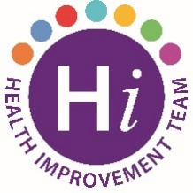 **For more information, visit the BWell site**

[Stop Smoking | B Well Belfast](https://bwellbelfast.hscni.net/positive-choices/stop-smoking/)