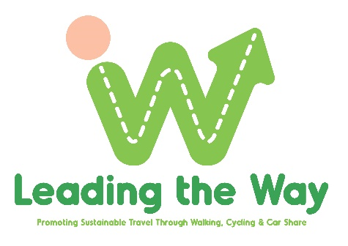
What’s coming up April/May2022

Re-invent your wheels day
At Sustrans Active Travel Hub, CS Lewis Square
Wednesday 6th April 11am – 3.00pm
- Book in for a free mechanical check with Dr Bike*
- Register your bike with the National Bike Register/PSNI*
- Come see our Borrow a Bike fleet
- Chat to Sustrans staff
Dr Bike (booking essential*) here: https://www.eventbrite.com/e/303333276997
Bike Register (booking essential*) here: https://www.eventbrite.com/e/303390919407

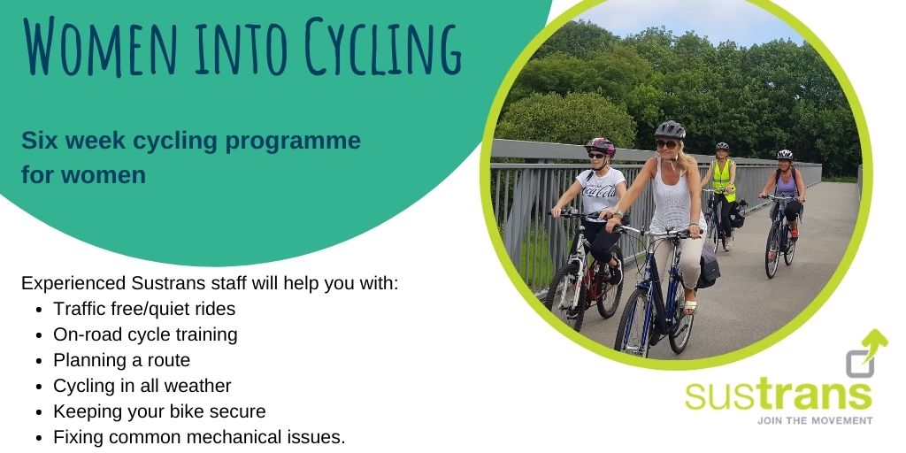

Gain confidence back in the saddle with other like-minded women eager to get cycling again. 6-week programme, first week on zoom then every week at CS Lewis Square. Bikes & helmets can be provided on request.
Starting Thursday 21st April 7pm – 9pm
Book here: https://www.eventbrite.com/e/292100750207
Or
Starting Tuesday 24th May 6.30pm – 8.30pm
Book here: Women into Cycling 6-week programme Registration, Tue 24 May 2022 at 18:30 | Eventbrite

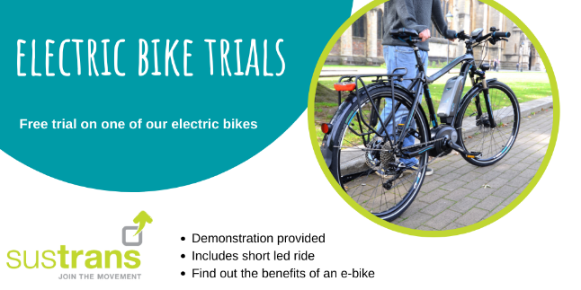

Thinking about buying an e-bike? Come and experience a traffic free session on one of Sustrans e-bikes at CS Lewis Square. Contact Dianne.whyte@sustrans.org.uk to arrange a session.
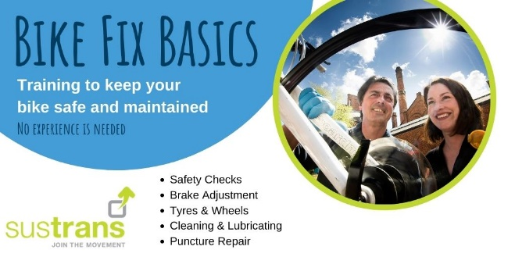
Unsure of how to fix a puncture, it's easy when you know how. Gain new knowledge, skills and pick up some complimentary saddle bag essentials for your journey.
Saturday 23rd April 10am – 12 noon, Connswater Community Centre, East Belfast
Book here: https://www.eventbrite.co.uk/e/bike-fix-basics-connswater-community-centre-registration-305076731717

