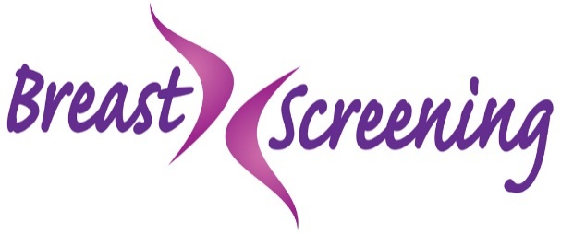

Happy International Women’s Day!
A day dedicated to women to show how strong and special all women are. It’s important to look after yourself not just today but every day!
With things still a little different this year with Covid19, it is still important to check your breasts and be breast aware.
If you notice a change or are worried about your breasts, please still contact your GP.
If you are aged 50 -70 and think you have missed your recent screening appointment, simply contact your local screening unit where staff can check if your screening is up to date.
If you are over 70 you will stop receiving screening invitations. If you want breast screening, you can arrange an appointment by contacting your local screening unit.
Early detection means best protection!

Tel: 028 90333700
Email: BreastScreeningLHST@belfasttrust.hscni.net
Breast Screening | B Well Belfast (hscni.net)

