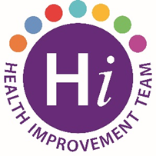National Stress Awareness Week
3rd November is Stress Awareness Day and the Health Improvement Team are here to help staff address the impact that stress has on our lives.
Our Top Tips for Looking After Yourself workshops help you understand the causes or stress in your life and reflect on how you deal with stress - do you turn to comfort food, a few drinks or just bury your head in the sand and keep going? This workshop can help you develop healthier and more effective habits to deal with stress.
Top Tips for Looking After Yourself is 2 hour online programme, suitable for anyone who’d like information on how to manage stress and improve their emotional wellbeing.
A series of programmes are available for staff on the dates below – these are booking up fast!
To register for one of the programmes contact health.improvement@belfasttrust.hscni.net
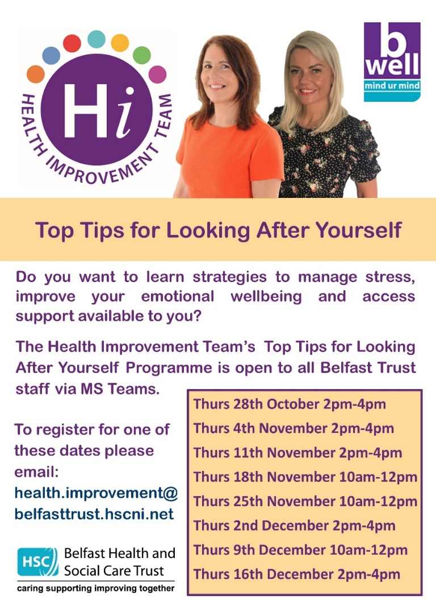
For more information on this programme and other mental health and suicide prevention training offered by the Health Improvement Team contact Clare Flynn clare.flynn@belfasttrust.hscni.net.
You can also visit B Well Mind ur Mind for further information and resources.

