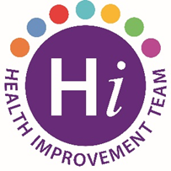Alcohol Awareness Month
November is Alcohol Awareness Month – a good time to consider your drinking habits.
Did you know?
- The NHS now advises that there is no 'safe' drinking level.
- If you drink less than 14 units a week, this is considered low-risk drinking.
- It's called "low risk" rather than "safe" because there's no safe drinking level.
- The type of illnesses you can develop after 10 to 20 years of regularly drinking more than 14 units a week include:
- cancers of the mouth, throat and breast
- stroke
- heart disease
- liver disease
- brain damage
- damage to the nervous system
- There's also evidence that regular drinking at high-risk levels can make your mental health worse.
The effects of alcohol on your health will depend on how much you drink. The less you drink, the lower the health risks.
The www.drugsandalcoholni.info website is full of information and support including an anonymous alcohol test to help you determine the impact that alcohol may be having on your health and wellbeing. Click the image below to take the test. You can also visit B Well Positive Choices Alcohol for information including a unit calculator.
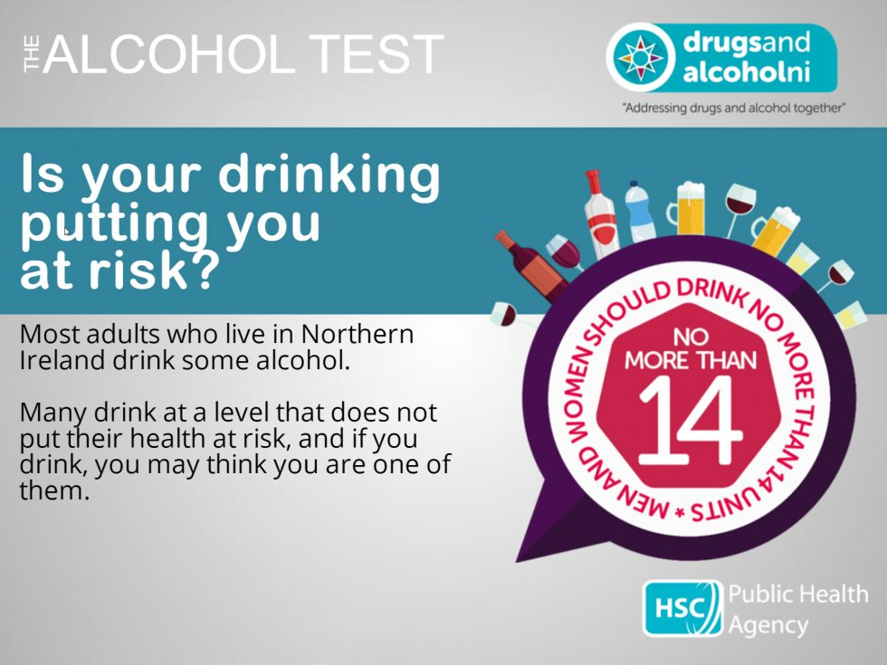

https://www.nhs.uk/live-well/alcohol-support/the-risks-of-drinking-too-much/

