HERE4U CHRISTMAS MACRAME

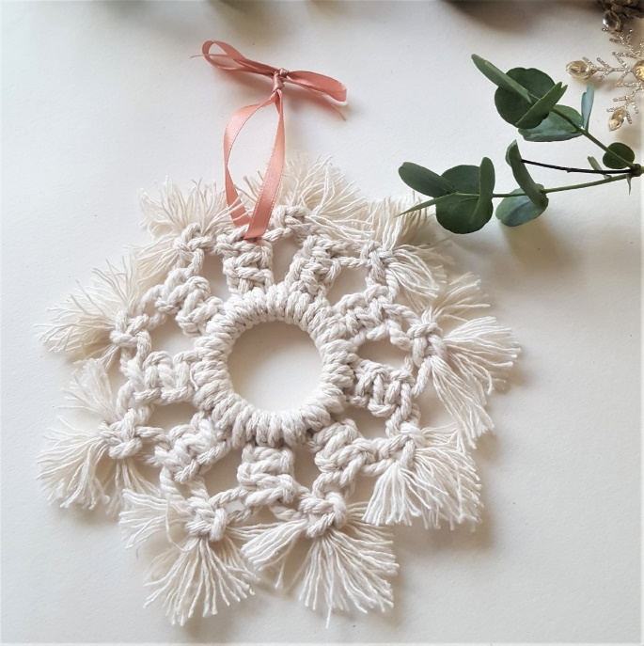

Thursday 25th November, 7.30-8.30 pm
OR
Monday 29th November, 7.30-8.30 pm

It’s time to get creative … Would you like to make this Christmas Star?

To register for this online Here4U Macrame class, please register using the attached registration form. Email your completed form to: vivien.lovell@belfasttrust.hscni.net

Please note: you will need to provide your personal email and home addresses on the registration form. This information is required to enable your Instructor to send the class Zoom link directly to you and to post the materials pack to your home.

* Closing date is Monday 8th November - places are limited

