

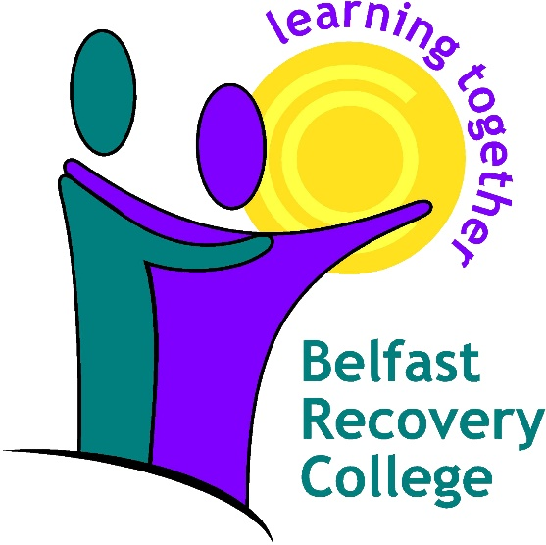

**INTERIM WEBINAR PROSPECTUS**

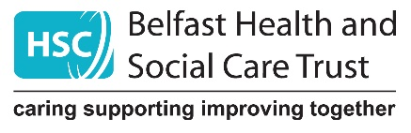

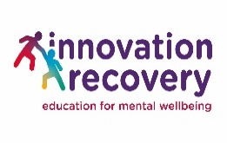**** ** cid:image013.jpg@01D5A12D.6F3B1180

A project supported by the European Union’s INTERREG VA Programme, managed by the Special EU Programmes Body

# WELCOME TO THE BELFAST RECOVERY COLLEGE WEBINAR PROGRAMME

The Belfast Recovery College warmly welcomes you to enrol for our free wellbeing and mental health interim webinar programme. A range of webinar education classes are open to everyone in the community of Belfast until we can resume our face-to-face courses in the future. We are keeping this under review.

For our webinars all you have to do is enrol!

Follow the easy steps to enrol below.

Contact the Recovery College to request our enrolment form

by either:

**E:**

[RecoveryCollege@belfasttrust.hscni.net](mailto:RecoveryCollege@belfasttrust.hscni.net)

**T: 028 9504 3059**

The enrolment form is available for download from the Belfast Recovery College webpage <https://belfasttrust.hscni.net/service/belfast-recovery-college/>

Once you have completed the enrolment form and returned it, you will be a student of the Belfast Recovery College( You will only have to complete this form once)

You can notify us of webinars you wish to enrol in by either email or telephone.  
**T: 028 9504 3059**E: [RecoveryCollege@belfasttrust.hscni.net](mailto:RecoveryCollege@belfasttrust.hscni.net)

We will send you a reminder text or email before your webinar is due to begin.

If you are unable to attend please let us know ASAP so another student can avail of the place.



Here at the Belfast Recovery College we use Microsoft Teams to deliver our webinars. There are two ways to join our webinars:

1 You can either access it through your internet browser

or

2 Through the free Microsoft Teams application.

**Internet Browser (like Chrome /Edge / Explorer /Firefox)**

To access it with your web internet browser you need:

* Go to the meeting invite you got in your email from us and select join Microsoft Teams meeting.
* That'll open a web page, where you'll see two choices: Download the Windows app and Join on the web instead.
* Enter your name and choose your audio and video settings.
* When you're ready, hit join now.
* This will bring you into the meeting lobby.
* We’ll let you in from there!

**To access teams through the application you need**

To access the courses in the Teams application you will need to have downloaded the Microsoft Teams application from your device’s app store and have a Microsoft account (there is no fee associated with this).

Either way you are most welcome to join our FREE Belfast Recovery webinar!

We recommend accessing our webinars on a PC, Laptop or Mac computer. It may be possible to access our webinars on other devices but we cannot be sure they are compatible with all devices, especially older or less powerful devices. If you have received confirmation that you have reserved a space on one of our webinars an invitation to join the webinar is sent to your registered email address. This will be on the day shortly before the course is due to run.

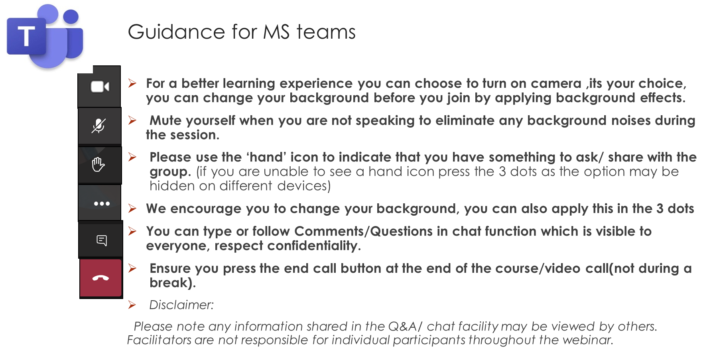

**Webinar Programme**

|  |  |  |  |
| --- | --- | --- | --- |
| **Course** | **Course Description** | **Date** | **Time** |
| Understanding Anxiety | This two-part webinar will help you develop an understanding of what anxiety is, why we experience it, and how it may affect us. We also explore practical strategies to manage it, including basic cognitive behavioural and relaxation techniques. If you or someone you know struggle(s) with anxiety or panic, including as a result of the Covid-19 pandemic, this course could be for you. | 1st April & 8th April. | 11am |
| Identity and Mental Health | This course will explore what identity means for us personally and how identity can be affected by mental ill health. We will look at ways of discovering our own identities and how to define ourselves in helpful and healthy ways. | 2nd April | 11am |
| Coping with Loneliness | During this pandemic, many people have felt an increased sense of loneliness. This course is aimed to increase our understanding of loneliness and its consequences, with practical tips to help us overcome feeling lonely. | 7th April | 2pm |
| Understanding Depression | Depression is the “leading cause of disability worldwide” (WHO, 2020) and can potentially affect anyone. This two-part webinar explores signs, symptoms and definitions of depression, stigma, and the condition’s possible causes. We also examine potential treatment and how someone experiencing depression might ask for help. We will also look at basic self-management strategies and cognitive behavioural techniques and briefly examine support for carers. | 13th & 14th April | 11am |
| Introduction to Psychological Therapies | Different styles of therapy can suit different individuals, situations and times, so further information may help to make the best choice. Staff who attend may want a better understanding of psychological therapies for themselves, or to help when considering a referral to psychological therapies for someone they are working with | 16th April | 2pm |
| Building Resilience | Resilience plays a key role in wellbeing especially in the challenges and restrictions of Covid19. Resilience is about developing flexibility, acceptance and self-compassion. This educative course will guide the student to an accessible roadmap to developing and maintaining resilience. | 15th April | 2pm |
| Understanding Anxiety | This two-part webinar will help you develop an understanding of what anxiety is, why we experience it, and how it may affect us. We also explore practical strategies to manage it, including basic cognitive behavioural and relaxation techniques. If you or someone you know struggle(s) with anxiety or panic, including as a result of the Covid-19 pandemic, this course could be for you. | 20th & 27th April | 11am |
| Mindfulness & Self Care | This course will discuss the link between compassion, self-compassion and the importance of self-care in order to nurture our wellbeing | 21st April | 2pm |
| Introduction to Psychological Therapies | Different styles of therapy can suit different individuals, situations and times, so further information may help to make the best choice. Staff who attend may want a better understanding of psychological therapies for themselves, or to help when considering a referral to psychological therapies for someone they are working with | 30th April | 2pm |
|  |  |  |  |

***We encourage all students to turn on their cameras to improve the overall student learning experience.***

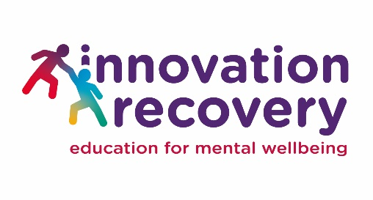

**The Innovation Recovery Project is funded by INTERREG VA monies via the Special EU Programmes Body and through the Co-operation and Working Together (CAWT) Partnership.**

The Project seeks to increase staffing and courses in conjunction with Recovery Colleges already in place, as well as establish a cross-border Recovery College network between the Republic of Ireland and Northern Ireland to support people in their recovery journey.

As well as our usual co-produced courses, a virtual Recovery College will be established for those who may have difficulty accessing in-person classes.

Belfast Recovery College and Innovation Recovery Project staff are working in tandem as one team to provide the range of courses listed in this prospectus.